**VIETNAM NATIONAL UNIVERSITY – HOCHIMINH CITY**

**INTERNATIONAL UNIVERSITY**

**SCHOOL OF ELECTRICAL ENGINEERING**



**IOT-BASED APPLICATIONS FOR WATER**

**RESOURCE MONITORING SYSTEM**

**BY**

**NGUYỄN TRUNG TÍN**

**EEACIU19063**

A THESIS submitted to the School of Electrical Engineering

in partial fulfillment of the requirements for

the degree of Bachelor of Engineering IN CONTROL ENGINEERING AND AUTOMATION

Ho chi minh city, vietnam

June 2025

**IOT-BASED APPLICATIONS FOR WATER**

**RESOURCE MONITORING SYSTEM**

BY

**NGUYỄN TRUNG TÍN**

**EEACIU19063**

Under the guidance and approval of the committee, and approved by its members, this thesis has been accepted in partial fulfillment of the requirements for the degree.

Approved by:

________________________________   
Chairperson

________________________________  
Committee member

________________________________Committee member

________________________________  
Committee member

________________________________  
Committee member

________________________________  
Committee member

# HONESTY DECLARATION

My name is Nguyễn Trung Tín. I would like to declare that, apart from the acknowledged references, this thesis either does not use language, ideas, or other original material from anyone; or has not been previously submitted to any other educational and research programs or institutions. I fully understand that any writings in this thesis contradicted to the above statement will automatically lead to the rejection from the Control Engineering and Automation program at the International University – Vietnam National University Ho Chi Minh City.

Date: 10/06/2025

Nguyễn Trung Tín

# TURNITIN DECLARATION

Name of Student: Nguyễn Trung Tín

Date: 10/06/2025

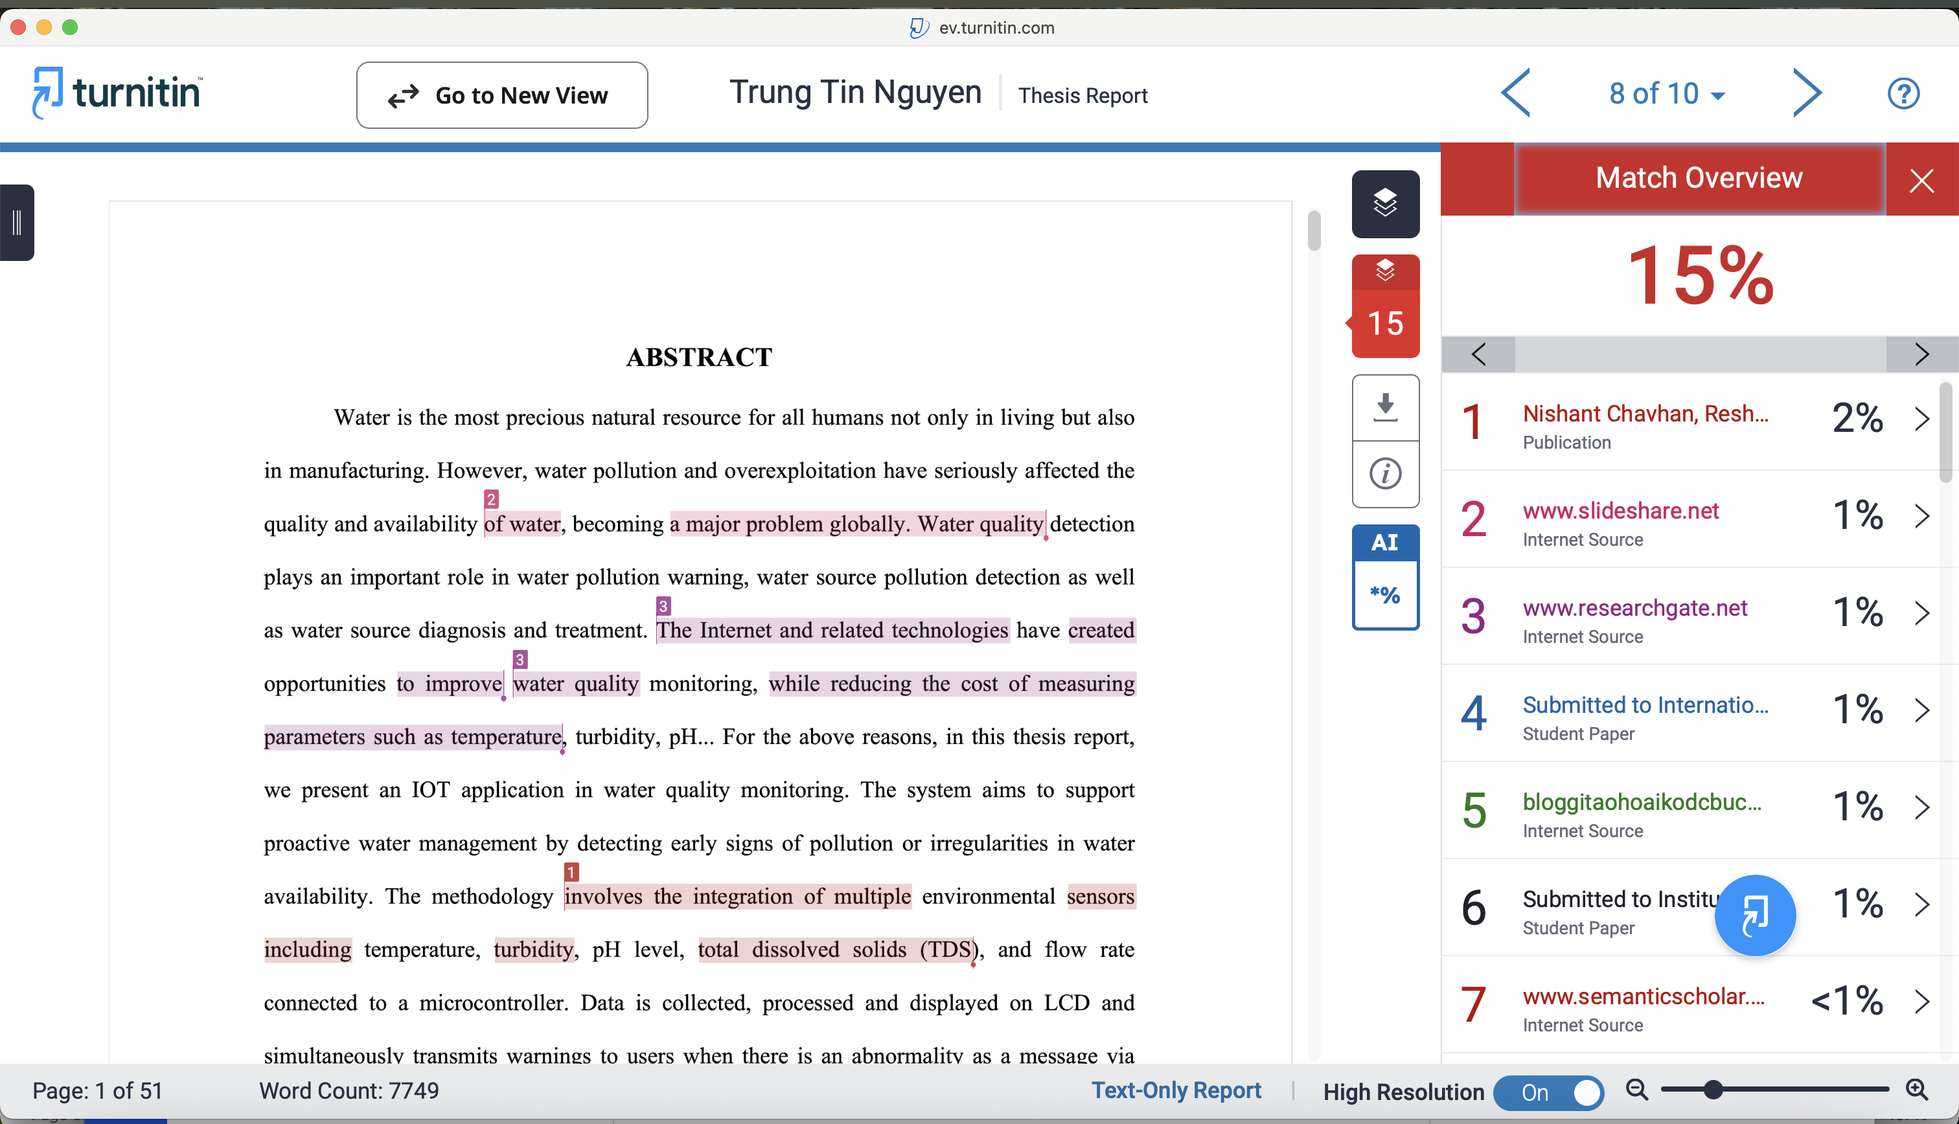

Advisor Signature Student Signature



Vương Quốc Bảo Nguyễn Trung Tín

__________________ __________________

Date: 10/06/2025 Date: 10/06/2025

# ACKNOWLEDGEMENT

It is with deep gratitude and appreciation that I acknowledge the professional guidance of Dr. Vương Quốc Bảo. His constant encouragement and support helped me to achieve my goal. I would like to express our sincere gratitude to all the individuals who have contributed valuable knowledge to the success and completion of this capstone. Firstly, I would like to express my appreciation to my advisor, Dr. Vương Quốc Bảo for his constructive feedback, encouragement, and guidance in completing this project with his valuable experience. Dr. Vương Quốc Bảo’s professional attitude and working style are an excellent model for us to follow. Secondly, I would also like to thank the lecturers and staffs of the School of Electrical Engineering for imparting valuable knowledge to us. Furthermore, I would like to thank our friends, colleagues, and family for their unwavering support and valuable advice.

# TABLE OF CONTENTS

HONESTY DECLARATION ii

TURNITIN DECLARATION iii

ACKNOWLEDGEMENT iv

TABLE OF CONTENTS v

LIST OF TABLES viii

LIST OF FIGURES ix

ABBREVIATIONS AND NOTATIONS xi

ABSTRACT xii

CHAPTER I. INTRODUCTION 1

1. 1. Theoretical background 1

1. 1. 1. The importance of water resources and current challenges in Viet Nam 1

1. 1. 2. IoT applications in daily life 2

1. 1. 3. The reason for choosing the topic: IOT-Based Applications for Water Resource Monitoring System 3

1. 2. Goals and objectives 4

1. 2. 1. Goal 4

1. 2. 2. Objectives 4

1. 3. The structure of the thesis 4

CHAPTER II. DESIGN SPECIFICATIONS AND ENGINEERING STANDARDS 6

2. 1. Design Specifications 6

2. 1. 1. System overview 6

2. 1. 2. Functional requirements. 6

2. 1. 3. Wifi standard 7

2. 1. 4. Cellular Communication Standard (4G LTE) 7

2. 2. Engineering Codes and Standards 7

2. 3. Realistic constraints 8

CHAPTER III. PROJECT MANAGEMENT 10

3. 1. Budget and Cost Management Plan. 10

3. 2. Project schedule 11

3. 3. Resource Planning 11

CHAPTER IV. LITERATURE REVIEWS 12

4. 1. Existing IoT based water quality monitoring systems. 12

4. 1. 1. First article: Design & Implementation of Water Quality Monitoring & Notification System [9]. 12

4. 1. 2. Second article: Design and Implementation of a Smart Water Monitoring System (IoT) Using Arduino Microcontroller [10]. 14

4. 1. 3. Third article: Real-time Water Quality Monitoring and Notification System for Aquaculture [11] 16

4. 2. Proposed methodology for this thesis 18

CHAPTER V. METHODOLOGY 19

5. 1. Flow chart 20

5. 2. Hardware design 21

5. 2. 1. Temperature sensor 21

5. 2. 2. pH sensor. 22

5. 2. 3. Turbidity Sensor 23

5. 2. 4. TDS sensor (Total Dissolved Solids) 24

5. 2. 5. Ultrasonic sensor. 25

5. 2. 6. Flow Sensor and DC pump 26

5. 2. 7. Wifi module. 27

5. 2. 8. 4G module. 27

5. 2. 9. GPS module 28

5. 2. 10. Power Supply. 29

5. 3. Software design. 29

5. 3. 1. Drawing the schematic. 29

5. 3. 2. Blynk. 30

CHAPTER VI. RESULTS 31

6. 1. Results 31

6. 1. 1. Hardware design. 31

6. 1. 2. Software design. 32

6. 1. 3. Evaluate the system performance in different environments. 36

6. 1. 4. Flow rate measurement results 42

6. 1. 5. Warning system test results. 43

6. 2. QR code for test data archive 45

6. 3. Discussions 45

6. 3. 1. Discussion 1 45

6. 3. 2. Iterative decision-making process 46

CHAPTER VII. CONCLUSIONS AND FUTURE WORK 49

7. 1. Conclusions. 49

7. 2. Future work. 49

CHAPTER VIII. BUSINESS, SOCIAL AND ETHICAL CONSIDERATIONS 51

8. 1. Business considerations 51

8. 2. Social considerations 51

8. 3. Ethical considerations 51

REFERENCES 52

APPENDICES 54

# LIST OF TABLES

Table 2. 1: Engineering Codes and Corresponding Standards 7

Table 2. 2: Realistic Constraints 8

Table 3. 1: Table of estimated costs. 10

Table 5. 1: Technical parameters of pH sensor [13] 23

Table 6. 1: pH correction package specifications 37

Table 6. 2: Number of pulses measured per liter in 10 calibration runs 42

Table 6. 3: Iterative decision-making process 46

# LIST OF FIGURES

Figure 3. 1: Project schedule 11

Figure 4. 1: Block diagram showing connections of all components [9] 13

Figure 4. 2: Prototype of water quality monitoring & notification system [9] 13

Figure 4. 3: Block diagram of the project [10] 14

Figure 4. 4: Flow chart diagram of the project [10] 15

Figure 4. 5: Image of the final project work [10] 16

Figure 4. 6: Conceptual Diagram of Water Quality Monitoring and Notification System [11]. 17

Figure 4. 7: The major components of the system [11] 17

Figure 5. 1: Block diagram of the system. 19

Figure 5. 2: System flowchart of the IoT-Based Water Resource Monitoring System 21

Figure 5. 3: Dallas temperature sensor (DS18B20) 22

Figure 5. 4: Analog PH sensor 22

Figure 5. 5: Turbidity sensor 24

Figure 5. 6: TDS sensor 24

Figure 5. 7: Classification of TDS levels in water (ppm) [14] 25

Figure 5. 8: Ultrasonic sensor (HC-SRF04). 25

Figure 5. 9: YF-S401 sensor 26

Figure 5. 10: Pump motor 385 12V DC 27

Figure 5. 11: The ESP8266 Wi-Fi module. 27

Figure 5. 12: A7682S module. 28

Figure 5. 13: GPS Module 28

Figure 5. 14: DC Voltage Reduction Circuit LM2596. 29

Figure 5. 15: Schematic of the system on Proteus software. 29

Figure 6. 1: Hardware system. 31

Figure 6. 2: Blynk application interface on smartphone. 32

Figure 6. 3: LCD display 33

Figure 6. 4: 4G module in operating state. 33

Figure 6. 5: SIM connection success notification and sensor data. 34

Figure 6. 6: ESP8266 module successfully connects to the Wi-Fi network. 34

Figure 6. 7: GPS module connected successfully 34

Figure 6. 8: Real time GPS coordinates and location link displayed on Blynk app 35

Figure 6. 9: GPS link from blynk app and location on google maps 35

Figure 6. 10: Blynk application interface displaying sensor parameters. 36

Figure 6. 11: pH correction package. 37

Figure 6. 12: Hardware system when operating with low pH water samples. 38

Figure 6. 13: Blynk interface shows pH measurement result is 4.02 with other indicators 38

Figure 6. 14: The litmus test results showed that the pH was at 4. 39

Figure 6. 15: Hardware system when operating with pH = 6.96 water samples. 39

Figure 6. 16: Blynk interface shows pH measurement result is 6.85 with other indicators 40

Figure 6. 17: The litmus test results showed that the pH was at 6 40

Figure 6. 18: Hardware system when operating with high pH water samples 41

Figure 6. 19: Blynk interface shows pH measurement result is 8.81 with other indicators 41

Figure 6. 20: The litmus test results showed that the pH was at 10 41

Figure 6. 21: LCD display with WF = 1.86 l/m 43

Figure 6. 22: Turbidity alert on Blynk 43

Figure 6. 23: SMS alert with turbidity: 619 NTU 44

Figure 6. 24: Distance alert on Blynk 44

Figure 6. 25: SMS alert with distance: 200 44

Figure 6. 26: QR Code leading to thesis results folder 45

# ABBREVIATIONS AND NOTATIONS

GPRS: General Packet Radio Service

GSM: Global System for Mobile Communications

IoT: Internet of Things

ISO: International Standard Organization

NTU: Nephelometric Turbidity Units

Ppm: Parts per million

TDS: Total dissolved solids

WSN: Wireless Sensor Network

# ABSTRACT

Water is the most precious natural resource for all humans not only in living but also in manufacturing. However, water pollution and overexploitation have seriously affected the quality and availability of water, becoming a major problem globally. Water quality detection plays an important role in water pollution warning, water source pollution detection as well as water source diagnosis and treatment. The Internet and related technologies have created opportunities to improve water quality monitoring, while reducing the cost of measuring parameters such as temperature, turbidity, pH, etc. For the above reasons, in this thesis, we implement an Internet of Things (IoT) application system in water quality monitoring. The system aims to support proactive water management by detecting early signs of pollution or irregularities in water availability. The methodology involves the integration of multiple environmental sensors including temperature, turbidity, pH level, total dissolved solids (TDS), flow rate and GPS connected to a microcontroller. Indeed, data is collected from these sensors, processed and displayed on LCD and simultaneously transmits warnings to users when there is an abnormality as a message via mobile using 4G module (A7682S). Moreover, the system leverages the Blynk Internet of Things platform for real-time remote visualization and warning notification. The implemented system was tested under different conditions such as acidic, neutral, and alkaline environments. The results demonstrate that the system provides accurate sensors reading, timely alerts. In conclusion, the proposed IoT-based water resource monitoring system is a reliable, low-cost, and scalable solution that can support household water resource monitoring and management.

**Keywords:** Microcontroller, sensors, water quality monitoring, GSM Module, LTE Module

# INTRODUCTION

In this chapter, there are three main parts including theoretical background, goal and objectives, and structure of the senior report.

## Theoretical background

This section will be divided into 3 small parts including: (i) the importance of water resources and current challenges in Viet Nam, (ii) IoT applications in daily life and (iii) the reason for choosing the topic. These parts will be discussed in the following subsections.

### The importance of water resources and current challenges in Viet Nam

Water covers approximately three-quarters of the Earth's surface and is a valuable resource for sustaining human life. In fact, around 70% of the planet’s surface is water, but only 2.5% of it is freshwater, with the remaining 97.5% found in the oceans [1]. Of the available freshwater, just 0.3% is contained in rivers and lakes, about 30% exists as groundwater, and the majority is locked away in glaciers and ice caps [1]. Globally, water usage is divided among agriculture (70%), industry (22%), and domestic purposes (8%) [2].

The combined effects of industrialization, modernization, and climate change are exerting significant pressure on the quality and quantity of global water resources. Water depletion, rising demand for clean water, and deteriorating water quality are major challenges facing humanity. Currently, more than 2.6 million people worldwide lack access to basic sanitation, and nearly 1 billion people are without clean drinking water [2]. Every 20 seconds, a child dies from diseases linked to inadequate access to clean water and proper sanitation [2]. A recent World Bank report estimates that by 2030, global water demand will exceed supply by 40% [1].

Currently, many major cities — particularly Hanoi and Ho Chi Minh City — still lack adequate access to clean water for daily use. Groundwater resources are being exploited uncontrollably, with widespread drilling of wells to extract underground water. This not only leads to waste and depletion but also risks contaminating these water sources. Additionally, due to a lack of awareness about the importance of water resources, improper management of landfills, burial sites, and waste treatment facilities occur across the country. These sites often fail to comply with regulations and environmental protection procedures, allowing leachate to seep into groundwater sources and flow into saltwater areas.

With the growing scarcity and pollution of water resources, the need for effective monitoring and management of water quality has become more urgent than ever. These challenges call for advanced technological solutions to safeguard and manage precious water supplies. As a result, the application of water quality monitoring technology, particularly IoT systems equipped with smart sensors, not only ensures accurate measurements but also provides real-time data to support the timely detection and management of water pollution and depletion issues. This approach will be key to protecting water resources and ensuring the safety and quality of life for communities.

### IoT applications in daily life

The development of the Internet of Things (IoT) has a significant impact on production, business, life and society across various sectors, including infrastructure management, healthcare, construction and automation monitoring [3]. IoT is a rapidly expanding technology trend that enables internet-connected objects or devices to collect, process, and share information [4]. It is recognized as a technology that has established itself as a network of machines or devices capable of communicating with one another [4].

In recent years, IoT has emerged as one of the most important technologies. It helps people live and work more efficiently while enabling them to be proactive in managing their daily lives. In the field of water quality monitoring, IoT plays a vital role by providing automatic and intelligent monitoring solutions. For example, a real-time drinking water quality monitoring system based on a wireless sensor network was introduced in [5]. This system sent users SMS alerts with water quality parameters — including temperature, turbidity, and pH — using a Zigbee module. A similar system in [6], monitored the same parameters, transmitting the data to users via an XBee wireless module and displaying it on an LCD screen. When the parameters reached dangerous levels, a buzzer would sound an alert. Additionally, a real-time mobile water temperature monitoring system, designed to help aquaculture farmers optimize their operations, was presented in [7]. In this system, a Raspberry Pi acted as the microcontroller and connected to a mobile device via the internet. Finally, a comprehensive survey on water quality monitoring using wireless sensor networks (WSN) was provided in [8], highlighting the system’s heavy reliance on mobile networks.

### The reason for choosing the topic: IOT-Based Applications for Water Resource Monitoring System

The International Organization for Standardization (ISO) defines water quality monitoring as the process of collecting, measuring, and documenting or indicating various water characteristics, with the objective of evaluating compliance with specified water quality objectives [4]. Water quality describes the overall biological, physical, and chemical composition of the water. Therefore, assessing drinking water quality requires monitoring a range of physical, chemical, and biological parameters. This is where the application of IoT in water quality monitoring becomes essential, enabling continuous, accurate, and efficient data collection and analysis, which provides a solid foundation for informed decision-making in water management.

In this thesis, an IoT system was developed to measure water quality indicators, including pH, temperature, turbidity, total dissolved solids (TDS), and flow rate, with greater accuracy and efficiency than existing instruments. The device integrates multiple environmental sensors connected to an Arduino microcontroller, an ESP8266 module, a GPS module and a 4G module, enabling real-time data transmission to mobile devices via the Blynk IoT platform and SMS. Users can easily monitor water quality on their smartphones and receive immediate alerts when abnormalities are detected. With the ability to continuously collect data and send real-time notifications, the system enhances the efficiency of water resource monitoring, reduces operational costs, and optimizes response processes when issues arise.

## Goals and objectives

### Goal

In this thesis, we will design and development of an IoT-based system for monitoring water resources by measuring temperature, pH, turbidity, total dissolved solids (TDS), flow rate, and location. Sensor data is collected via a microcontroller and transmitted to a mobile app through Wi-Fi and 4G signals, with abnormal values triggering SMS alerts.

### Objectives

1. Review the existing techniques that use IoT approaches to monitor water quality.
2. Design and implement an IoT-based system to monitor water resources by measuring temperature, pH, turbidity, total dissolved solids (TDS), flow rate and location. The data will then be sent to the user via the Blynk platform and SMS message.
3. Evaluate the system performance in different environments.

## The structure of the thesis

The content of this thesis is divided into seven chapters. The chapter I provides about theoretical background, and it also presents the goals and objectives of the senior. The second chapter is design specifications and standards. The third chapter provides a budget and cost management plan, a project management plan, tasks to be performed, and specific timelines for each task, all displayed in a Gantt chart. Next are the references related to our project, providing knowledge and solutions for developing the water quality monitoring system presented in Chapter IV. The fifth chapter provides the methodology for achieving the objectives. Chapter VI presents the results. Finally, chapter VII discusses conclusions, implications, strengths, weaknesses and effectiveness of the system and future development prospects. Finally chapter VIII discusses about business, social and ethical of the thesis.

# DESIGN SPECIFICATIONS AND ENGINEERING STANDARDS

This chapter provides a detailed description of the hardware and software design of the IoT-based water resource monitoring system. It establishes a clear framework for the system design, including the architectural structure, functional requirements, and engineering constraints to ensure reliable and efficient operation. The system utilizes microcontrollers and various sensors to collect data, connects to WiFi and 4G modules, and transmits information to users over the network.

## Design Specifications

### System overview

The water quality monitoring system uses Arduino UNO and ESP8266 to connect temperature, pH, turbidity, total dissolved solids (TDS), flow rate, and geographic location sensors to WiFi and 4G module. The data will be transmitted to the Blynk application, where users can monitor the parameters in real time.

The index sensors include: DS18B20 sensor (temperature measurement), pH sensor, turbidity sensor, total dissolved solids (TDS), flow rate sensor and geographic location sensor.

The 4G module (A7628S) is used for communication via 4G network, ensuring monitoring capability in the absence of WiFi.

### Functional requirements.

* Measure key water parameters: temperature, pH, turbidity, TDS, flow rate and location.
* Collect data using an Arduino-based microcontroller.
* Display real-time readings on a local LCD screen.
* Transmit sensor data to the Blynk mobile application via Wi-Fi (ESP8266)
* Send SMS alerts via the A7682S 4G LTE module when abnormal values are detected.

### Wifi standard

The system uses the ESP8266 WiFi module, supporting the IEEE 802.11 b/g/n WiFi standard. This WiFi standard allows data transmission at speeds up to 150 Mbps in the 2.4 GHz band. This is a popular standard and is suitable for IoT applications thanks to its stable connection and good coverage in indoor and outdoor environments. In addition, this module supports security protocols such as WPA/WPA2, ensuring the safety of transmitted data.

### Cellular Communication Standard (4G LTE)

The system uses the A7682S 4G LTE module for mobile communication, which complies with the 3GPP LTE standards. LTE (Long-Term Evolution) provides higher data rates, lower latency, and better coverage compared to traditional GSM based modules. The A7682S module supports a variety of frequency bands and operates on the 4G network infrastructure, allowing data to be transmitted efficiently and reliably, especially in areas without Wi-Fi connectivity. This standard ensures stable and secure data communication for sending SMS alerts and supporting remote monitoring in IoT applications.

## Engineering Codes and Standards

**Table 2. 1:** Engineering Codes and Corresponding Standards

|  |  |  |
| --- | --- | --- |
| Element/Product/System | Engineering Standards | Comments |
| Electrical Safety | IEC 61140: Protection against  electric shock | Ensure proper insulation and grounding in circuit design |
| Embedded Systems Design | IEEE 1474: Guidelines for microcontroller-based systems | Guides integration of Arduino, ESP8266, and A7682S module |
| Wireless Communication (ESP8266 wifi, A7682S 4G) | IEEE 802.11 (Wi-Fi), 3GPP LTE (4G) standards | Governs wireless data transmission via Wi-Fi and 4G |
| Sensor Calibration and Accuracy (pH, TDS, turbidity, water flow, water level) | ISO 15839: Water quality online sensors for water monitoring | Ensures accurate and standardized measurement of water quality and quantity using calibrated sensors under real world environmental conditions |
| Environmental Data Handling | IEEE 1451: Smart sensor interface for transducers | Standardizes the way sensors communicate with the microcontroller |
| Data Security & Transmission | ISO/IEC 27001, WPA2, TLS protocols | Ensures secure transmission of data through Wi-Fi and 4G, especially for remote alerts |
| Power Supply Module (LM2596) | IEC 62368-1: Safety requirements for power supplies | Ensures safe low-voltage design and thermal protection for outdoor use |
| System Reliability & Maintenance | ISO 25010: Systems and software quality models | Ensures the system is robust, maintainable, and suitable for field applications |

## Realistic constraints

**Table 2. 2:** Realistic Constraints

|  |  |
| --- | --- |
| Area | Realistic Constraints |
| Economic | The system uses low-cost components such as Arduino UNO, ESP8266, and off-the-shelf sensors (pH, TDS, turbidity, temperature, GPS) to minimize total development cost while ensuring acceptable performance. This makes it feasible for use in rural areas or household settings. |
| Environment | Designed to operate under diverse environmental conditions, including high humidity and temperature fluctuations. Components are placed in water-resistant enclosures to maintain system reliability in outdoor or semi-exposed areas. |
| Social | The system promotes water safety awareness by enabling households and rural communities to access real-time water quality data, contributing to improved hygiene practices, better resource usage, and community health. |
| Ethical | Ensure accurate and transparent data collection to prevent misinformation, especially when warning users of unsafe water. The system operates under the principle of do-no-harm and prioritizes data integrity for public safety. |
| Sustainability | The use of low-power, durable hardware components and wireless transmission reduces energy consumption. Long-life components and the ability to calibrate sensors help extend the system’s operational lifespan with minimal environmental impact. |
| Health and Safety | The system monitors parameters critical to human health, such as pH, TDS, and turbidity. It provides automatic alerts when values exceed safety thresholds, helping prevent disease or contamination from poor water quality. |
| Manufacturability | Built using modular and widely available components, enabling easy replication, upgrade, and maintenance. Suitable for mass production or small-scale deployment in education, agriculture, or home use. |

# PROJECT MANAGEMENT

This chapter shows the project budget, cost management plan, project schedule and resource planning.

## Budget and Cost Management Plan.

Table 3.1 provides a description of how the project costs are managed. Provides detailed information on the costs of all components and equipment required for the project.

**Table 3. 1:** Table of estimated costs.

|  |  |  |  |
| --- | --- | --- | --- |
| Numbers | Description | Quantity | Cost |
| 1 | Arduino UNO R3 | 1 | 99,000 VND |
| 2 | ESP8266 (Node MCU) | 1 | 95,000 VND |
| 3 | LCD2004 | 1 | 82,000 VND |
| 4 | 4G module | 1 | 189,000 VND |
| 6 | GPS module | 1 | 200,000 VND |
| 7 | Temperature sensor | 1 | 20,000 VND |
| 8 | pH sensor | 1 | 1,100,000 VND |
| 9 | Turbidity sensor | 1 | 120,000 VND |
| 10 | Ultrasonic sensor | 1 | 30,000 VND |
| 11 | TDS sensor | 1 | 110,000 VND |
| 12 | Flow sensor | 1 | 77,000 VND |
| 13 | Other component |  | 500,000 VND |
| 14 | Other costs |  | 1,000,000 VND |
| 15 | Total |  | 3,622,000 VND |

## Project schedule

The project progress and timeline to achieve the goals and objectives are shown in the Gantt chart below

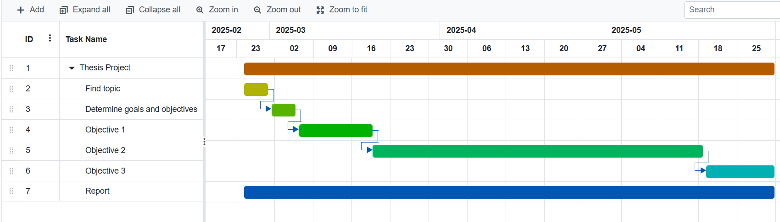

**Figure 3. 1:** Project schedule

## Resource Planning

Hardware resources: The system was built using low-cost components, including Arduino UNO, ESP8266, A7682S, various water quality sensors pH, turbidity, TDS, temperature, flow sensor, GPS module, and a 20x4 LCD.

Software tools: we will use the C programming language. All code will be developed on Arduino IDE software. There are main libraries we use: Wire.h, SoftwareSerial.h, OneWire.h, DallasTemperature.h, LiquidCrystal.h, ESP8266WiFi.h, TimerOne.h, BlynkSimpleEsp8266.h. Proteus was utilized for circuit simulation, and the Blynk platform was used for mobile-based monitoring

# LITERATURE REVIEWS

Based on section **1.2.2**, the first objective is to study the existing techniques using IoT approaches to monitor water quality. To achieve this objective, we have divided the literature review into two main sections: **4.1** Existing IoT based water quality monitoring systems and **4.2** Proposed methodology to be applied in this senior project. Below are details of each part.

## Existing IoT based water quality monitoring systems.

Recently, with the advancement of IoT standard, several IoT based solutions have been introduced for water quality monitoring such as the following articles.

### First article: Design & Implementation of Water Quality Monitoring & Notification System [9].

This paper presents a low-cost IoT-based solution for real-time water quality monitoring. The system uses sensors to measure pH, turbidity and temperature parameters, integrated with Arduino Mega microcontroller for data collection and processing. The results are displayed locally on the LCD screen and SMS notifications are sent via GSM module (SIM900A), helping users receive instant alerts when parameters are abnormal.

#### Hardware.

The hardware devices used include:

* Turbidity Sensor
* Temperature sensor
* PH sensor
* Ultrasonic sensor
* Arduino Mega Board
* GSM shield module
* LCD display

#### Block diagram and prototype of system.

Figure 4.1 shows the connection diagram of the components and Figure 4.2 is the prototype of the product.

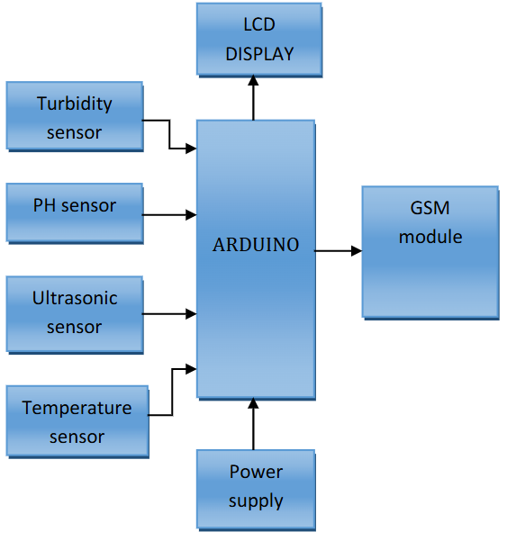

**Figure 4. 1:** Block diagram showing connections of all components [9]

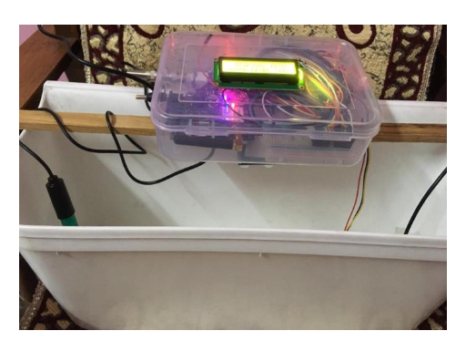

**Figure 4. 2:** Prototype of water quality monitoring & notification system [9]

### Second article: Design and Implementation of a Smart Water Monitoring System (IoT) Using Arduino Microcontroller [10].

This study presents a smart water monitoring system using IoT technology, focusing on real-time measurement of water quality and level. The system integrates multiple sensors, Arduino Mega microcontroller and Cayman IoT platform for data monitoring and visualization.

#### Proposed methodology.

The overall design of the water monitoring system is shown in Figure 4.3[10].

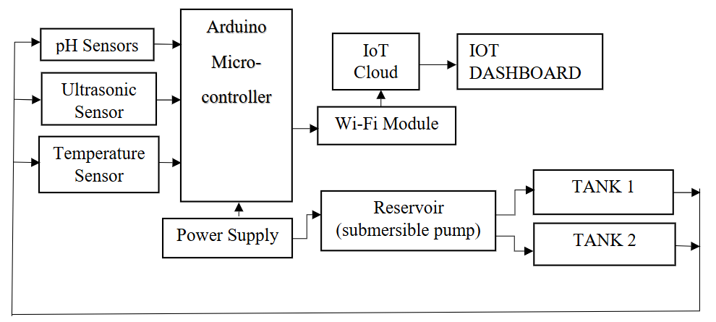

**Figure 4. 3:** Block diagram of the project [10]

The system consists of two tanks and a water reservoir connected, and a 5V DC pump system. Each tank is equipped with an ultrasonic sensor placed on top, which is responsible for monitoring the water level in the tank. When the water in the tank reaches the lowest level, the ultrasonic sensor will send a signal to the Arduino microcontroller to activate the pump, ensuring that water is pumped into the tank. Conversely, when the water reaches the highest level, the sensor will send a signal to turn off the pump, helping to prevent water overflow. The system operates fully automatically, ensuring effective management of the water level in the tanks.

A pH sensor is installed in the reservoir where water is pumped into the two tanks to assess safety for use. The pH value is displayed on the IoT dashboard, and if the pH is out of the neutral range (below 7 is acidic, above 7 is alkaline), the water will need to be filtered. The pH scale ranges from 0 to 14, with 7 being neutral, indicating a balance between acid and alkalinity [10]. Additionally, a temperature sensor is placed in the reservoir to measure the temperature of the water as it enters the tank, determining how hot or cold the water is.

The data collected from the sensor, including water level, pH, and temperature, is transmitted to the Cayenne myDevices IoT platform via a Wi-Fi module [10]. This platform allows for real-time analysis and visualization of values, helping users monitor and manage water quality effectively.

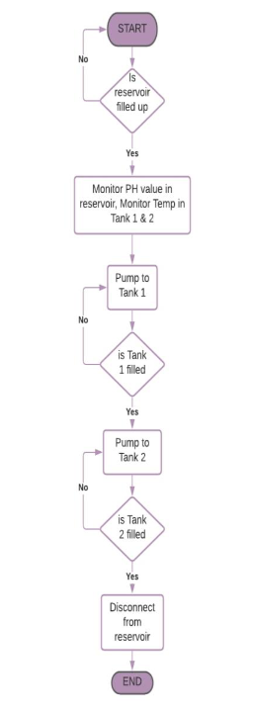Figure 4.4 is a flow chart of the system's operation.

**Figure 4. 4:** Flow chart diagram of the project [10]

#### Hardware.

These are the hardware devices as well as the final product developed in figure 4.5.

* Ph sensor
* Arduino mega
* Esp8266 wifi module
* Temperature sensor
* Ultrasonic sensor

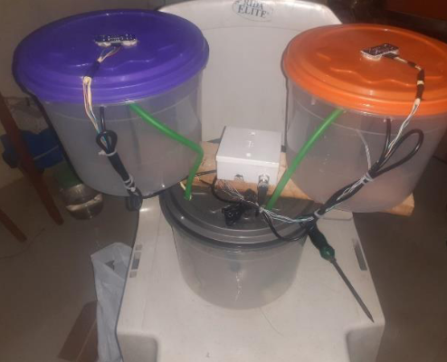

**Figure 4. 5:** Image of the final project work [10]

### Third article: Real-time Water Quality Monitoring and Notification System for Aquaculture [11]

This paper presents a water quality monitoring system that can automatically adjust four types of water quality parameters including temperature, potential hydrogen (pH) level, turbidity, and dissolved oxygen. The system uses Arduino Nano as the main controller, combined with NodeMCU (ESP8266) to transmit data via Firebase Realtime Database [11]. A mobile application is developed using React Native, supporting real-time value monitoring, receiving notifications when the indicators are out of standard, and providing appropriate action suggestions. The main purpose of the research is to develop a smart farm model using IoT to raise fish at high density in a closed system to be environmentally friendly and sustainable [11].

#### Hardware design.

Key features include:

* Monitoring and reporting abnormal values.
* Customizing water quality thresholds.
* Displaying historical data in a visual graph.

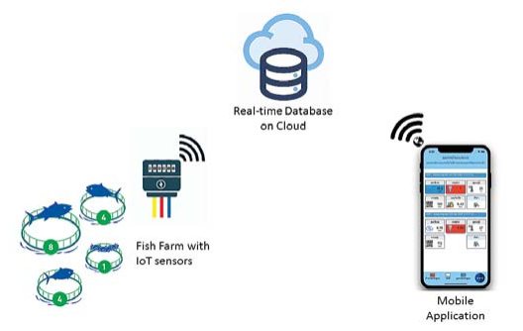Figure 4.6 below illustrates the conceptual framework and main components of the system and Figure 4.7 shows the main components of the hardware system.

**Figure 4. 6:** Conceptual Diagram of Water Quality Monitoring and Notification System [11].

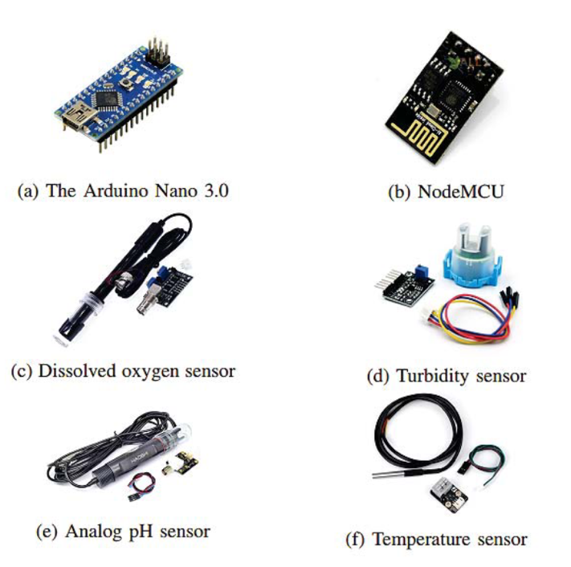

**Figure 4. 7:** The major components of the system [11]

## Proposed methodology for this thesis

Through the studies of related documents in section **4.1**, it can be observed that many water quality monitoring systems have been developed based on IoT technology. Most of them use sensors to measure important parameters such as temperature, pH, dissolved oxygen and turbidity, combined with connection modules to transmit data in real time or over the network. The study by Katole and colleagues(section **4.1.1**)used Arduino Mega, temperature, pH, turbidity sensors, and GSM module to collect, analyze water quality data and send SMS notifications to users. This system allows real-time monitoring and alerts when parameters exceed safety thresholds. Similarly, Ogundele Joshua’s research (section **4.1.2**) focused on monitoring water quality and water levels in tanks, combined with the Cayenne IoT platform to display data via an online dashboard. This research highlights the flexibility and integration of IoT in remote water monitoring, making it easy for users to check important indicators from anywhere. And Jomsuda Duangwongsa’s research (section **4.1.3**) successfully implemented a system using Arduino Nano, NodeMCU (ESP8266) and Firebase Realtime Database to monitor water in aquaculture ponds, providing information directly via a mobile application. These studies are important references for developing the method in my project.

Based on the results and techniques from the above studies, this project applies pH, temperature, turbidity, total dissolved solids (TDS), flow and GPS sensors with an Arduino UNO microcontroller, displays parameters on LCD screen and transmitted via Wi-Fi using the ESP8266 module to the Blynk mobile application. Simultaneously, a 4G LTE communication module (A7682S) is employed to send SMS alerts to users when critical thresholds are exceeded. The difference is the flexible combination of two data transmission methods (WiFi and 4G), allowing the system to operate even without WiFi connection. This not only saves costs but also ensures providing real-time data and warnings when water parameters exceed thresholds.

# METHODOLOGY

Based on the goals and objectives in Chapter I and the analysis results from related studies in Chapter IV, the overall design of the water monitoring system is shown in Figure 5.1

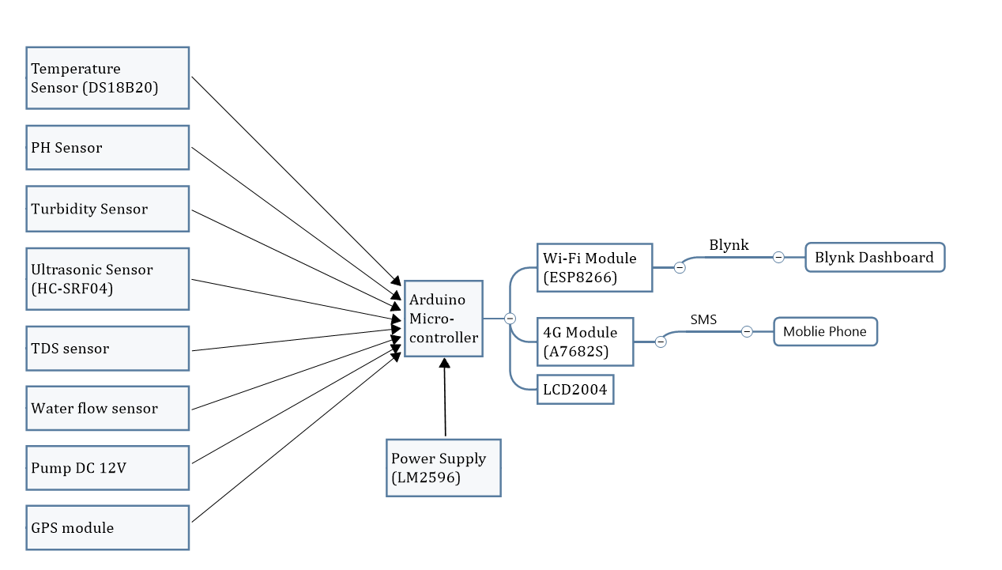

**Figure 5. 1:** Block diagram of the system.

The methods will be described in detail in this chapter. It is organized into four main sections:

1. Flow chart
2. Hardware design
3. Software design
4. Proposed model

## Flow chart

Figure 5.2 illustrates the flowchart of the IoT-based water resource monitoring system. The process begins with establishing connections between the Arduino UNO microcontroller, all environmental and location sensors, the ESP8266 Wi-Fi module, and the A7682S 4G LTE module via a hotspot or Wi-Fi connection. Once connections are successfully initialized, the system continuously reads water-related parameters from the following sensors:

* Temperature sensor (DS18B20): Measures the water temperature.
* pH sensor: Detects the acidity or alkalinity of the water.
* Turbidity sensor: Monitors water clarity.
* TDS sensor: Measures the total dissolved solids concentration.
* Flow sensor: Calculates the water flow rate during pumping.
* Ultrasonic sensor (SRF04): Estimates the water level inside the container.
* GPS module: Provides real-time geographical location of the monitoring unit.

The collected analog or digital signals are processed by the Arduino UNO. The sensor readings are then:

* Displayed on a 20x4 I2C LCD for local on-site observation.
* Transmitted to the ESP8266 module and forwarded to the Blynk Cloud for real-time monitoring via a mobile application.

If any measured parameter exceeds its predefined threshold, a warning is triggered in the Blynk interface by activating a red virtual LED. Simultaneously, an SMS alert is sent via the A7682S 4G LTE module to a predefined phone number to notify the user about the abnormal condition.

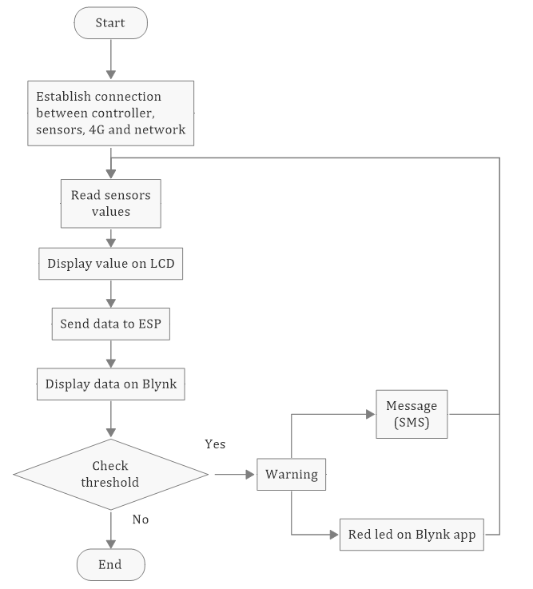

**Figure 5. 2:** System flowchart of the IoT-Based Water Resource Monitoring System

## Hardware design

The components used in this system are explained as follows.

### Temperature sensor

The Dallas temperature sensor shown in Figure 5.3 is a 1-wire programmable temperature sensor and measures temperature in the range of -55°C to +125°C with an accuracy of ±0.5°C [9]. The sensor has a durable, waterproof design, suitable for harsh environments such as chemical fluids or soil. The DS18B20 only needs one data pin of the microcontroller, in the system connected to pin 12 of Arduino UNO via 1-Wire protocol, Arduino collects temperature data from DS18B20 using the **OneWire.h** and **DallasTemperature.h** libraries.

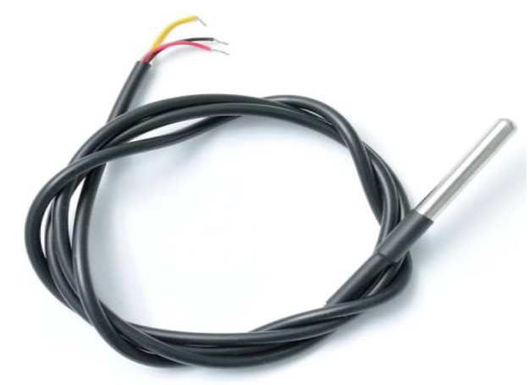

**Figure 5. 3:** Dallas temperature sensor (DS18B20)

### pH sensor.

pH (potential Hydrogen) is the acidity or alkalinity of water. The pH sensor module in figure 5.4 consists of pH sensor also called as pH probe and a signal conditioning board which gives an output which is proportional to the pH value and can be interfaced directly to any microcontroller [11].

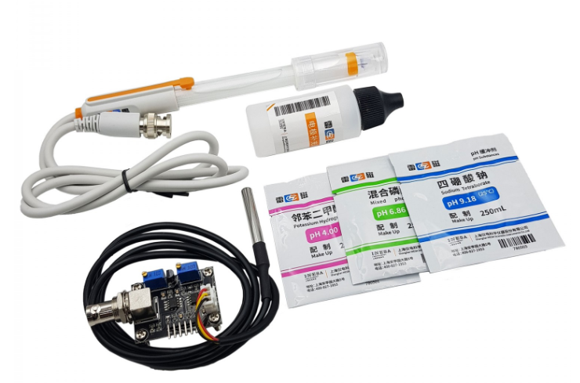

**Figure 5. 4:** Analog PH sensor

Technical parameters of pH sensor module E-201C is shown in Table 5.1.

**Table 5. 1:** Technical parameters of pH sensor [13]

|  |  |  |
| --- | --- | --- |
| Numbers | Parameters | Values |
| 1 | Power supply | 5VDC |
| 2 | Working current | 5 ~ 10mA |
| 3 | Power consumption | <0.5W |
| 4 | Return signal | Analog |
| 5 | PH measurement range | 0 - 14 pH |
| 6 | Response time | ≤ 5 seconds |
| 7 | Stabilization time | ≤ 60 seconds |
| 8 | Accuracy | ±0.1 pH (at 25°C) |
| 9 | Working temperature range | 0°C – 60°C (best at 20°C) |
| 10 | Working humidity range | 0% – 95% (best at 60%) |
| 11 | Response speed | < 1 minute |
| 12 | Weight | 25g |

The analog signal is connected to the **A0** pin of Arduino UNO. pH value ranges from 0-14, with 0 – 6 as acidic and 8 – 14 as alkaline. Acidic water tastes sour, while alkaline water tastes bitter or soap [12].

### Turbidity Sensor

Turbidity is the darkness or opacity of water due to the presence of many microscopic particles in the water that are invisible to the naked eye, like smoke in the air [9]. The turbidity sensor in figure 5.5 can detect water quality by measuring the level of turbidity/opacity in the water. It can detect suspended particles in water by measuring the scattering rate and transmittance, which vary with the amount of total suspended solids in the water. As the total suspended solids increase, the turbidity of the liquid also increases. The scale used by this sensor is Nephelometric Turbidity Units (NTU). In this system, the turbidity sensor outputs an analog voltage that is proportional to the water’s turbidity level. The analog signal is connected to the **A2** pin of Arduino UNO, where it is read and processed.

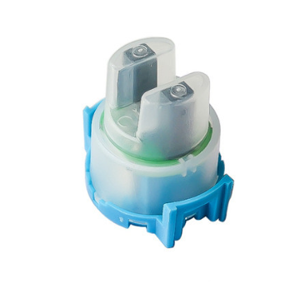

**Figure 5. 5:** Turbidity sensor

### TDS sensor (Total Dissolved Solids)

The TDS sensor shown in Figure 5.6 measures the concentration of total dissolved solids in water, with the unit expressed in parts per million (ppm). TDS represents the number of milligrams of dissolved solids present in one liter of water. The higher the TDS value, the greater the concentration of dissolved substances, corresponding to the lower purity of the water. The sensor connects to the Arduino's **A1** analog pin and is processed in real time along with other sensor data.

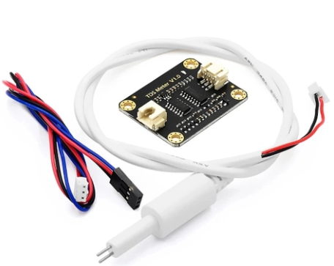

**Figure 5. 6:** TDS sensor

To better understand the implications of TDS levels on water quality, the figure 5.7 below provides a classification range:

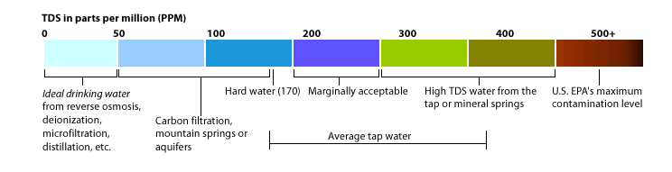

**Figure 5. 7:** Classification of TDS levels in water (ppm)[14]

* 0 – 100 ppm: ideal drinking water, water safe for human.
* 100 – 400 ppm: water for domestic use only
* Above 500 ppm: polluted water, absolutely do not use

### Ultrasonic sensor.

The ultrasonic sensor, as shown in figure 5.8 measures distance by transmitting ultrasonic waves and receiving the reflected waves from the target surface. In this system, the sensor is used to monitor the water level in the tank, determining whether it is empty or full. The sensor works by calculating the time taken for the ultrasonic waves to travel to the water surface and return, which is then converted into distance using the speed of sound.

The ultrasonic sensor is connected to the Arduino UNO with two pins:

**Trigger** pin: Sends out the ultrasonic signal (Pin 4 of Arduino UNO)

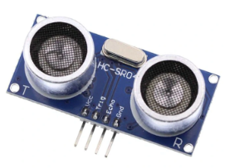**Echo** pin: Receives the reflected signal (Pin 5 of Arduino UNO)

**Figure 5. 8:** Ultrasonic sensor (HC-SRF04).

### Flow Sensor and DC pump

In this system, the water flow sensor employed is a hall sensor type (Figure 5.9), widely used in both residential and industrial applications due to its durability and reliable measurement capability. The sensor typically consists of three main components: a water inlet valve, a turbine-style rotor, and a hall magnetic sensor positioned near the rotor.

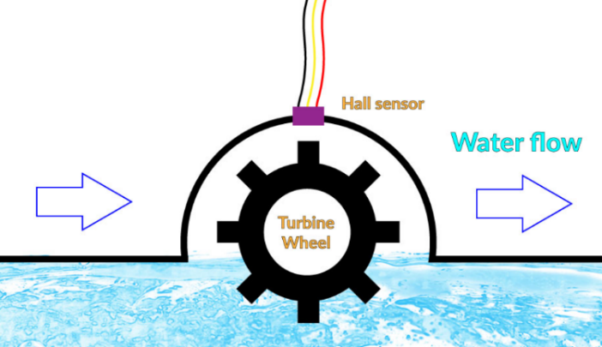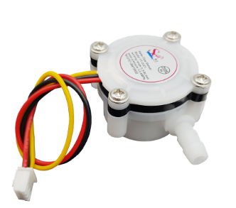

**Figure 5. 9:** YF-S401 sensor

When water passes through the valve, the water flow rotates the rotor, generating electrical pulses through the change in magnetic field at the Hall sensor location. The higher the flow rate, the higher the frequency of the pulses. These electrical pulses are sent to pin 2 of the Arduino.

In addition to the flow sensor, the system also integrates a pump motor with a pumping capacity of 1.5 liters to 2 liters of water per minute operating with a voltage of 12V DC (Figure 5.10), which is connected to digital pin 9 on the Arduino. The pump can be remotely switched on or off via the Blynk application by sending control commands over the serial interface from ESP8266 to the Arduino. Specifically:

Sending the character '1' turns the pump on.

Sending the character '2' turns the pump off.

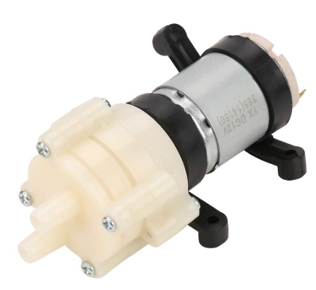

**Figure 5. 10:** Pump motor 385 12V DC

### Wifi module.

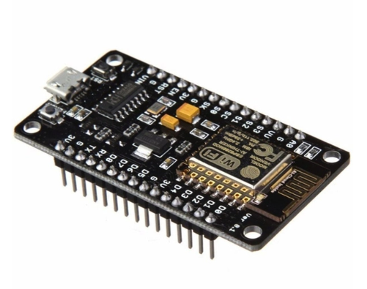The ESP8266 Wi-Fi Module, as shown in figure 5.11, is a self-contained system-on-chip (SoC) with an integrated TCP/IP protocol stack, enabling any microcontroller to connect to a Wi-Fi network. In this system, the ESP8266 is connected to the Arduino UNO via serial communication (TX/RX pins). Once the Internet connection is established, the module transmits data, including temperature, pH, and turbidity values, to the Blynk Cloud platform for remote monitoring.

**Figure 5. 11:** The ESP8266 Wi-Fi module.

### 4G module.

The 4G module, as shown in figure 5.12, is used to provide cellular communication capabilities for the system. It allows Arduino UNO to send and receive SMS alerts using the 4G network. In this system, A7682S is used to connect to Arduino UNO via serial communication (TX/RX pin).

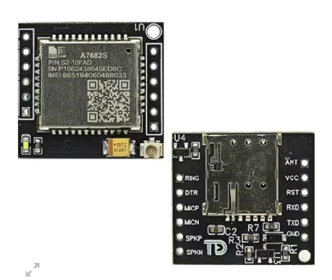

**Figure 5. 12:** A7682S module.

When the measured parameters such as temperature, pH, turbidity, distance and TDS exceed the pre-defined threshold value, the module will send an SMS alert to a designated phone number, ensuring that the user receives timely warnings about abnormal water quality conditions.

The A7682S 4G LTE module used in this system is compatible with all major mobile network providers in Vietnam, including Viettel, Vinaphone, and Mobifone. The module requires a stable power supply of 3.8V to 4.2V for normal operation, which is achieved through the DC-DC converter in the circuit.

### GPS module

The GPS module in figure 5.13 provides the real-time location of the monitoring station. It communicates with the ESP8266 via UART and is used to display longitude and latitude on the Blynk dashboard.

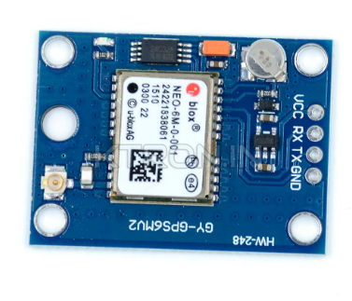

**Figure 5. 13:** GPS Module

### Power Supply.

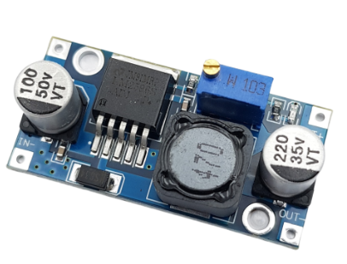The power supply module provides the necessary voltage and current to operate the entire system. In this system, a DC-DC converter (LM2596) in Figure 5.14 is used to step down the voltage from a 12V power source to 5V, ensuring compatibility with the components.

**Figure 5. 14:** DC Voltage Reduction Circuit LM2596.

## Software design.

### Drawing the schematic.

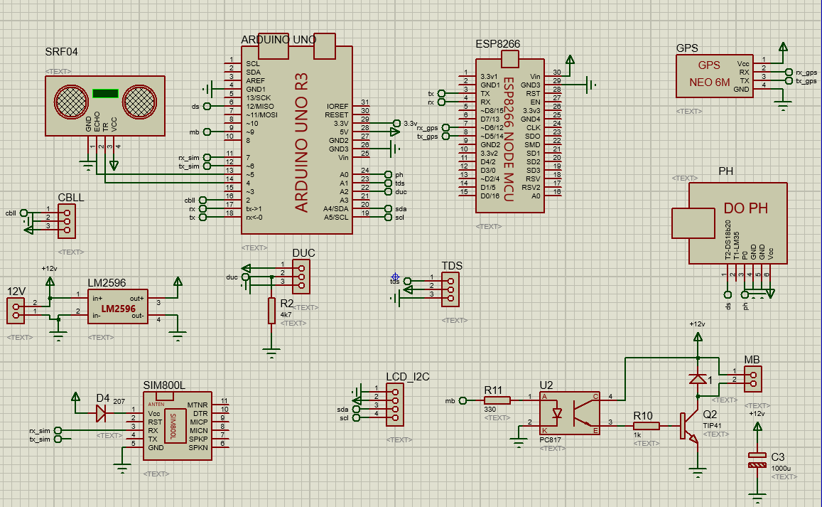From the components in section 5.2, figure 5.15 is the circuit diagram of the system drawn on proteus software.

**Figure 5. 15:** Schematic of the system on Proteus software.

### Blynk.

Blynk is an IoT platform that enables users to create custom mobile dashboards for monitoring and controlling hardware systems via IOS and Android devices. After downloading the Blynk application, users can design a virtual interface using various widgets such as buttons, sliders, and gauges. These widgets interact with the hardware through virtual pins, allowing for real time data display and control. In this project, the Blynk app is used to display real time sensor data collected from the water monitoring system. The following parameters are visualized:

* Temperature, measured by the DS18B20 sensor.
* pH level, measured by the analog pH sensor.
* Turbidity, indicating water clarity, measured by the turbidity sensor.
* Water level measured using the ultrasonic sensor (SRF04).
* Total dissolved solids (TDS), indicating water quality in ppm.
* Flow rate, calculated from the pulse-based flow sensor.
* Geographic location, obtained from the GPS module.

These values are sent from the ESP8266 Wi-Fi module to the Blynk cloud and then retrieved by the app for live display.

# RESULTS

In this chapter, we will show the results of this project.

## Results

### Hardware design.

Figure 6.1 is the complete hardware design for an IoT-based applications for water resource monitoring system, including main components such as sensors and the placement of components detailed on the circuit board below.

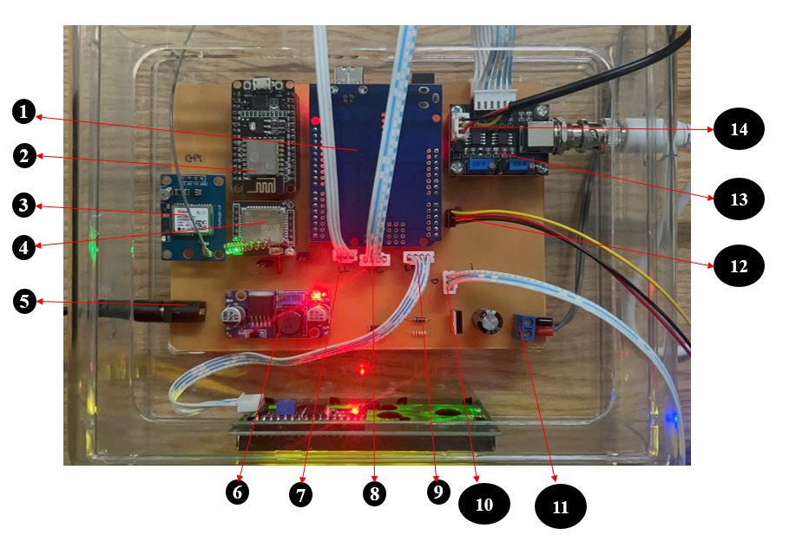

**Figure 6. 1:** Hardware system.

1. Arduino UNO R3
2. Wifi module (ESP8266)
3. GPS module
4. 4G module (A7862S)
5. Power jack
6. DC-DC converter (LM2596)
7. Flow sensor
8. Ultrasonic sensor (HC-SRF04)
9. LCD display
10. Turbidity sensor
11. Pump
12. TDS sensor
13. pH sensor
14. Temperature sensor (DS18B20)

### Software design.

#### Blynk app.

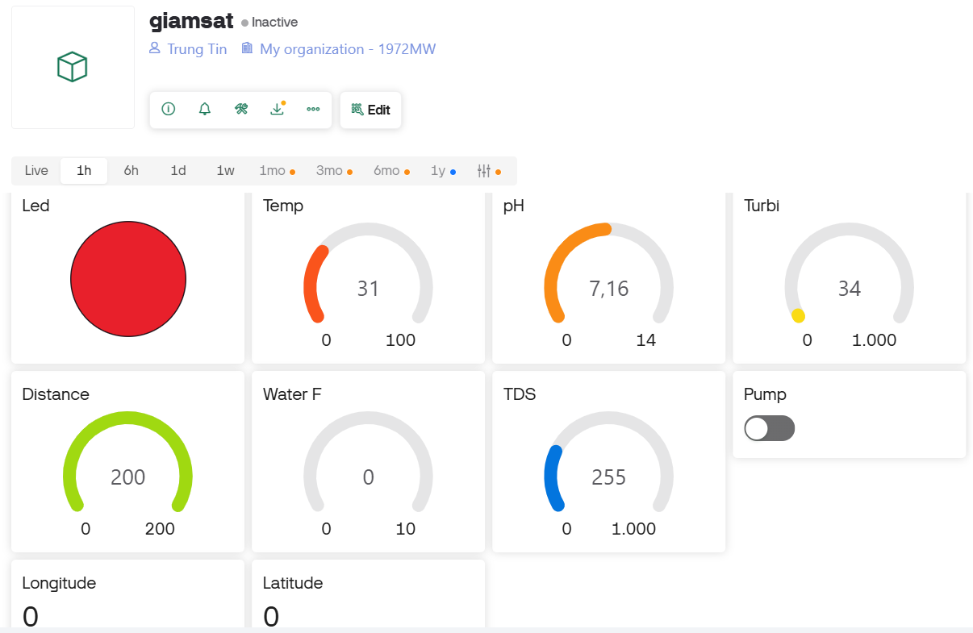Figure 6.2 shows the Blynk interface on a smartphone, displaying the measured parameters such as pH, temperature, water level turbidity, TDS and water flow. The longitude and latitude are read from the GPS module and a pump control switch. These values ​​are updated in real time via a Wi-Fi connection. In addition, an alarm is also triggered when the parameters exceed the safety threshold, indicated by a red LED on the control panel.

**Figure 6. 2:** Blynk application interface on smartphone.

#### System boot.

When the system starts, the LCD screen will display the message "INIT SIM... PLEASE WAIT..." (Figure 6.3) to signal that the system is checking and initializing the connection with the 4G module.

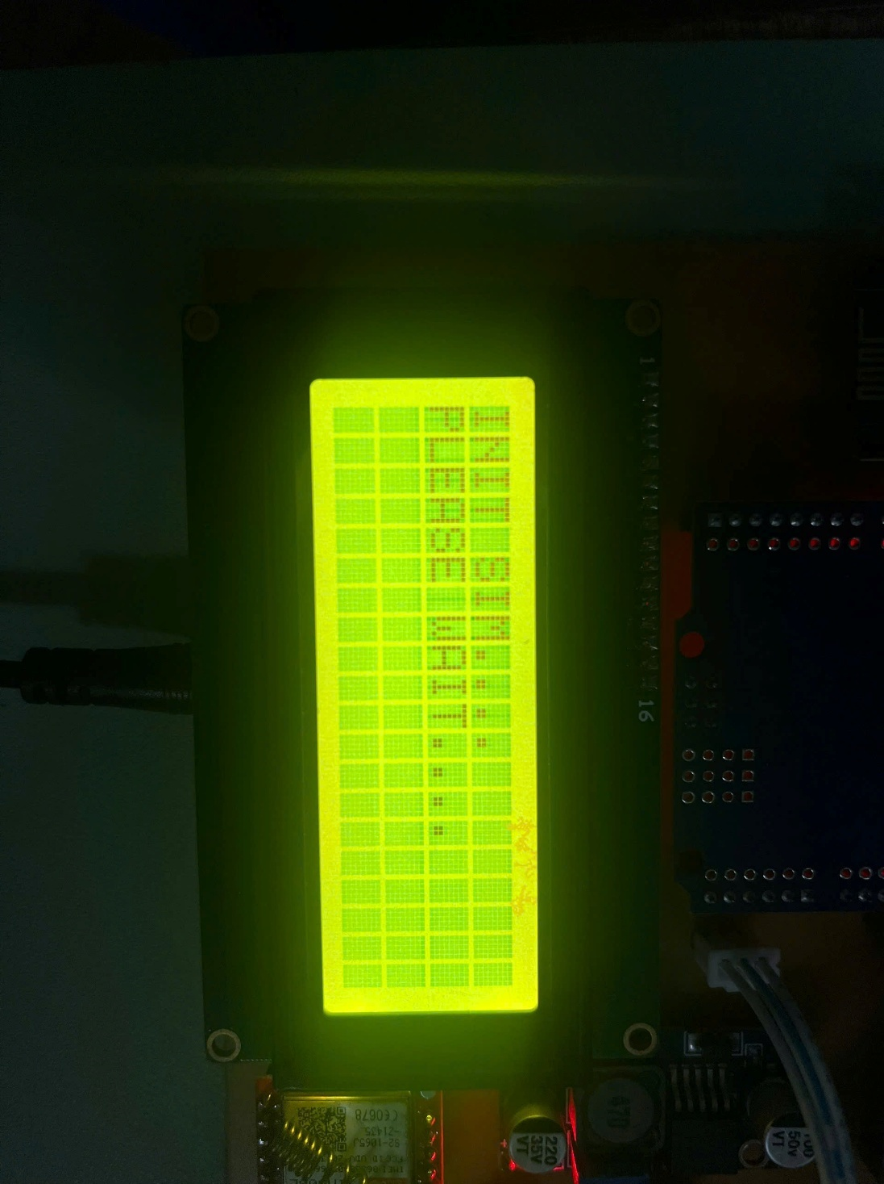

**Figure 6. 3:** LCD display

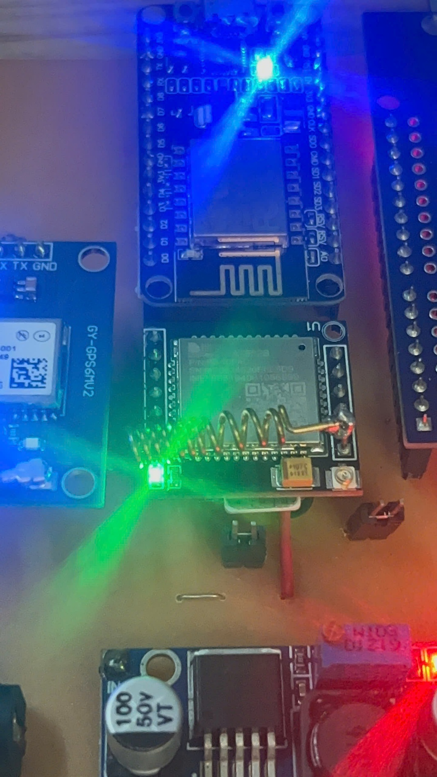If the connection is successful, the flashlight on the 4G module will blink as shown in Figure 6.4.

**Figure 6. 4:** 4G module in operating state.

And a message “START SUCCESSFUL” will be sent to the predetermined phone number, along with the parameters measured from the sensors at that time as in Figure 6.5.

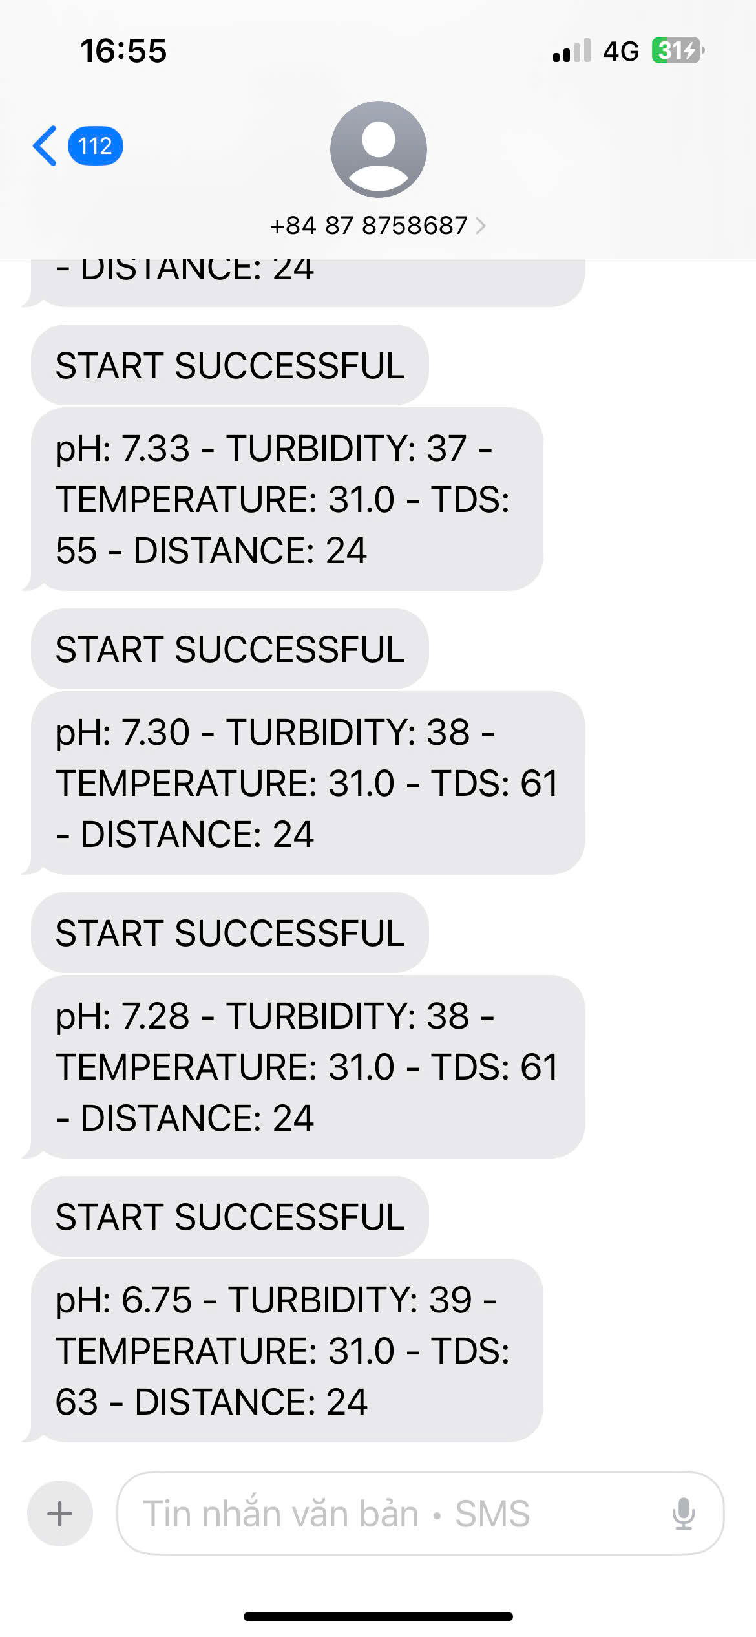

**Figure 6. 5:** SIM connection success notification and sensor data.

For Wi-Fi network connection, the ESP8266 module plays a role in ensuring the connection between the system and the Blynk application. When the ESP8266 module successfully connects to the Wi-Fi network and the Blynk application on the phone, the light on the module will light up, indicating the operating status as in Figure 6.6.

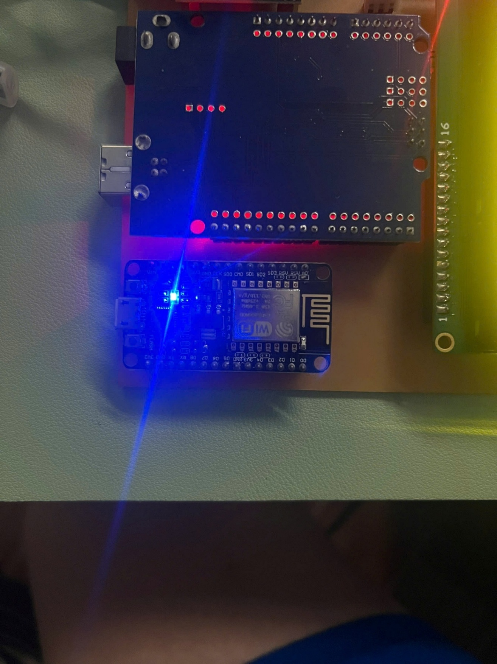

**Figure 6. 6:** ESP8266 module successfully connects to the Wi-Fi network.

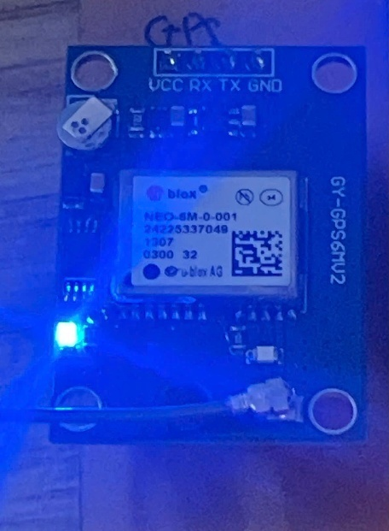For the 4G module, when the antenna captures the coordinates, the flash light on the module will blink as shown in Figure 6.7.

**Figure 6. 7:** GPS module connected successfully

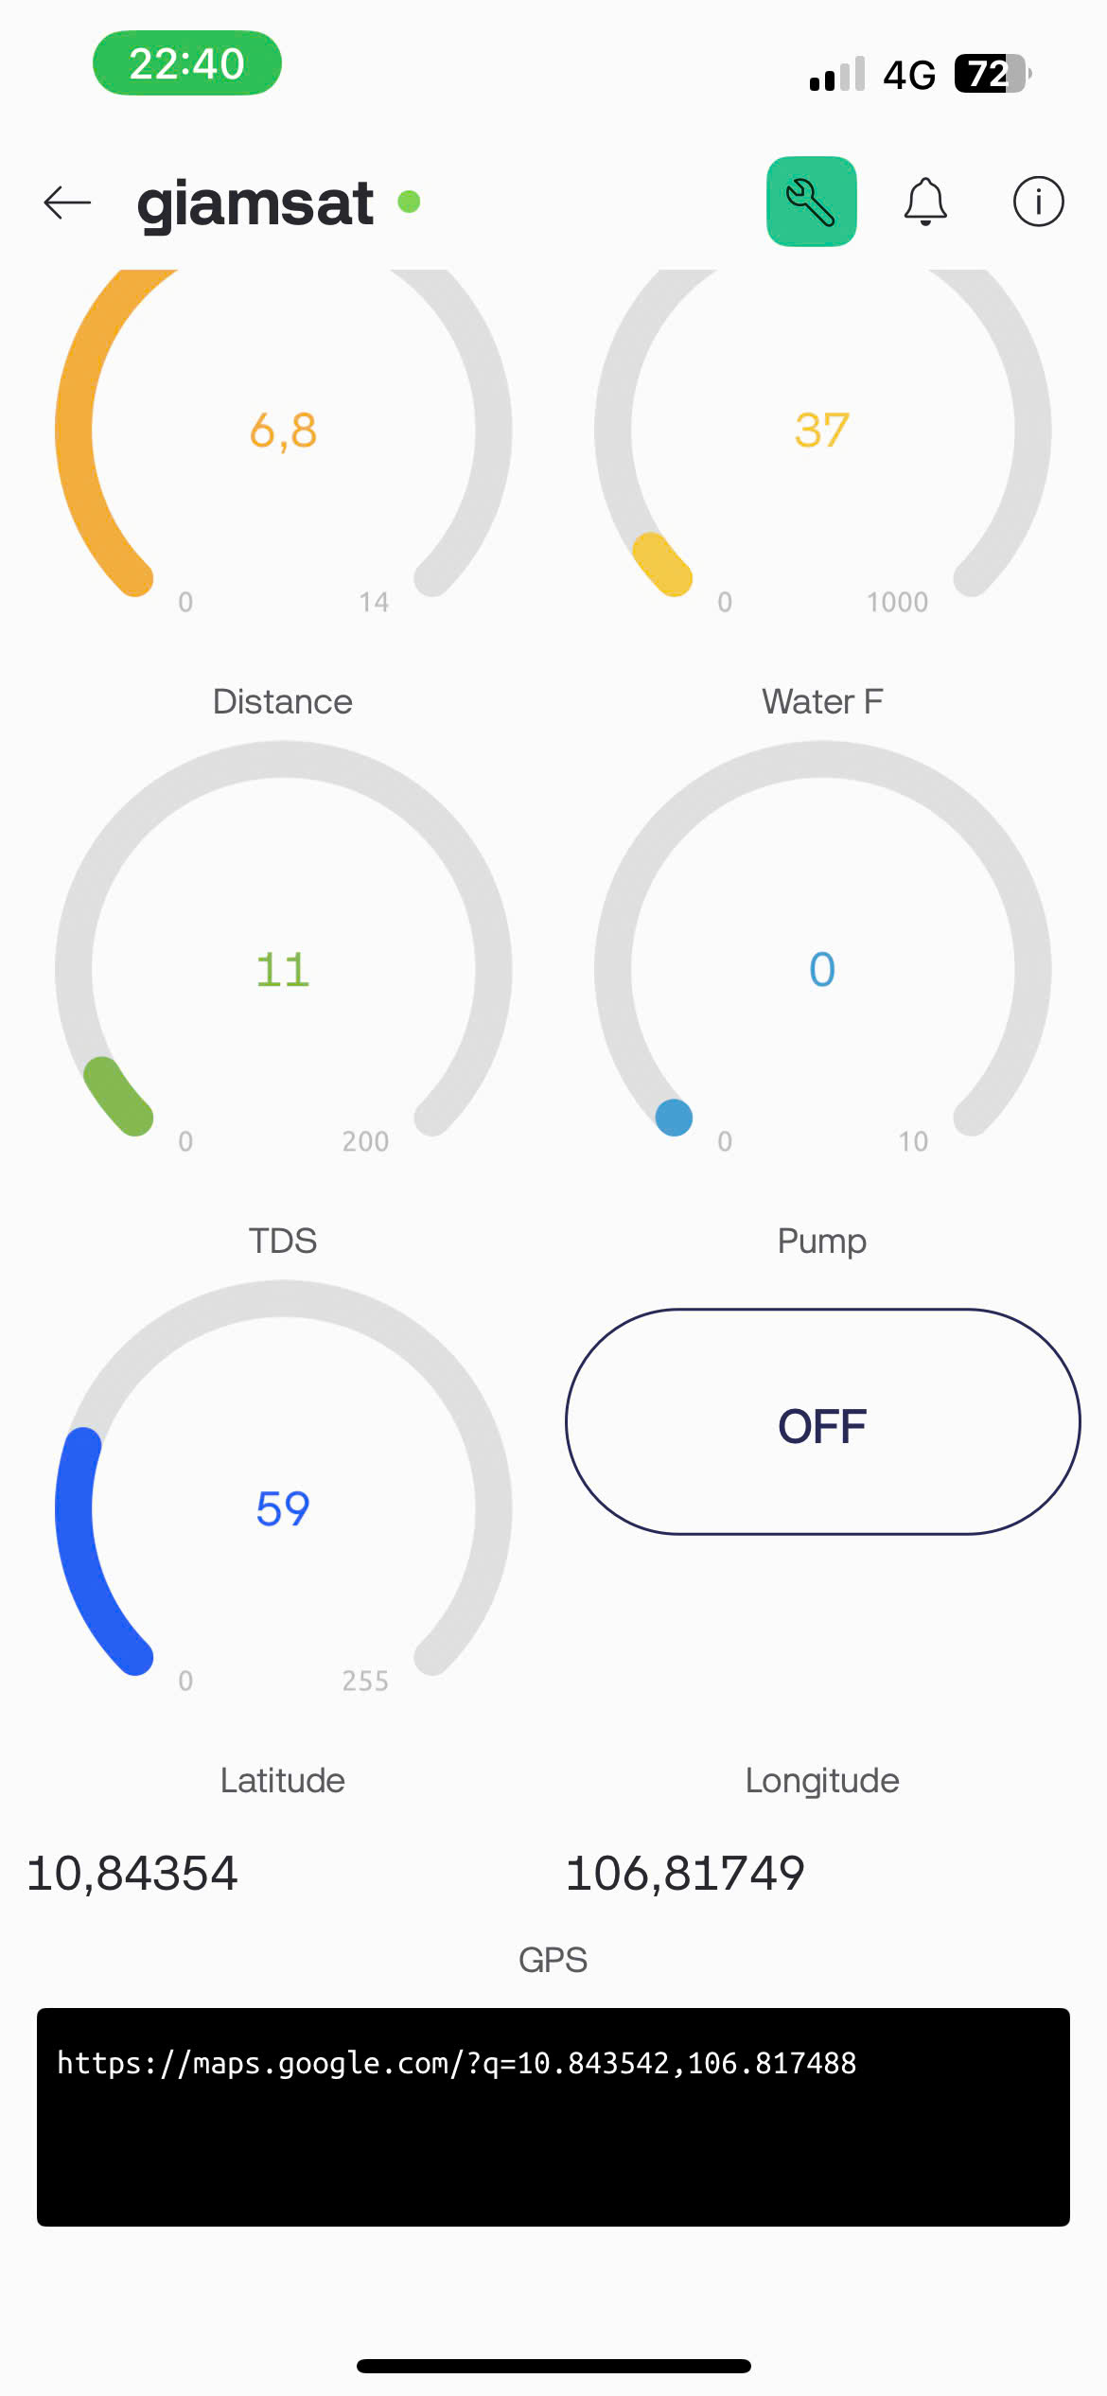At the same time, the latitude and longitude are also sent to the blink app and a google link is displayed on the terminal as shown in Figure 6.8.

**Figure 6. 8:** Real time GPS coordinates and location link displayed on Blynk app

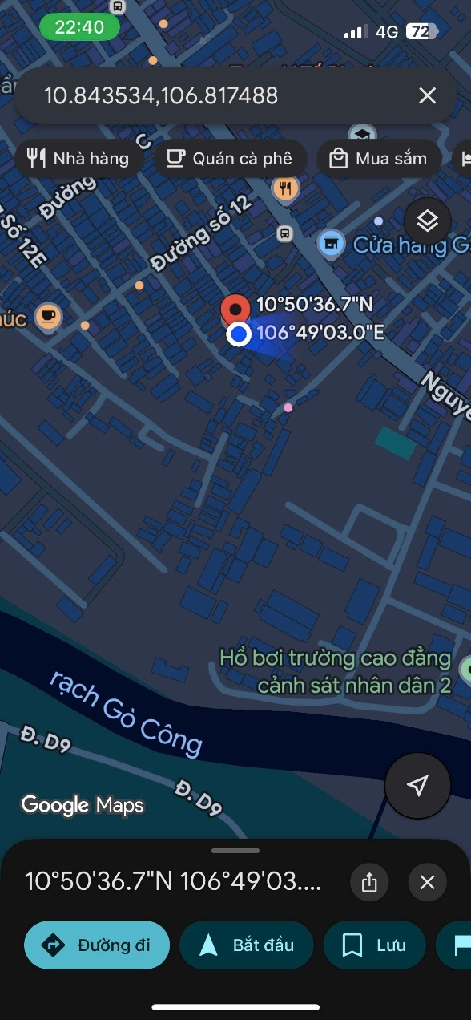When clicking on the link and selecting show on map, it will automatically switch to google map and show the location where the system is located. This is illustrated in Figure 6.9

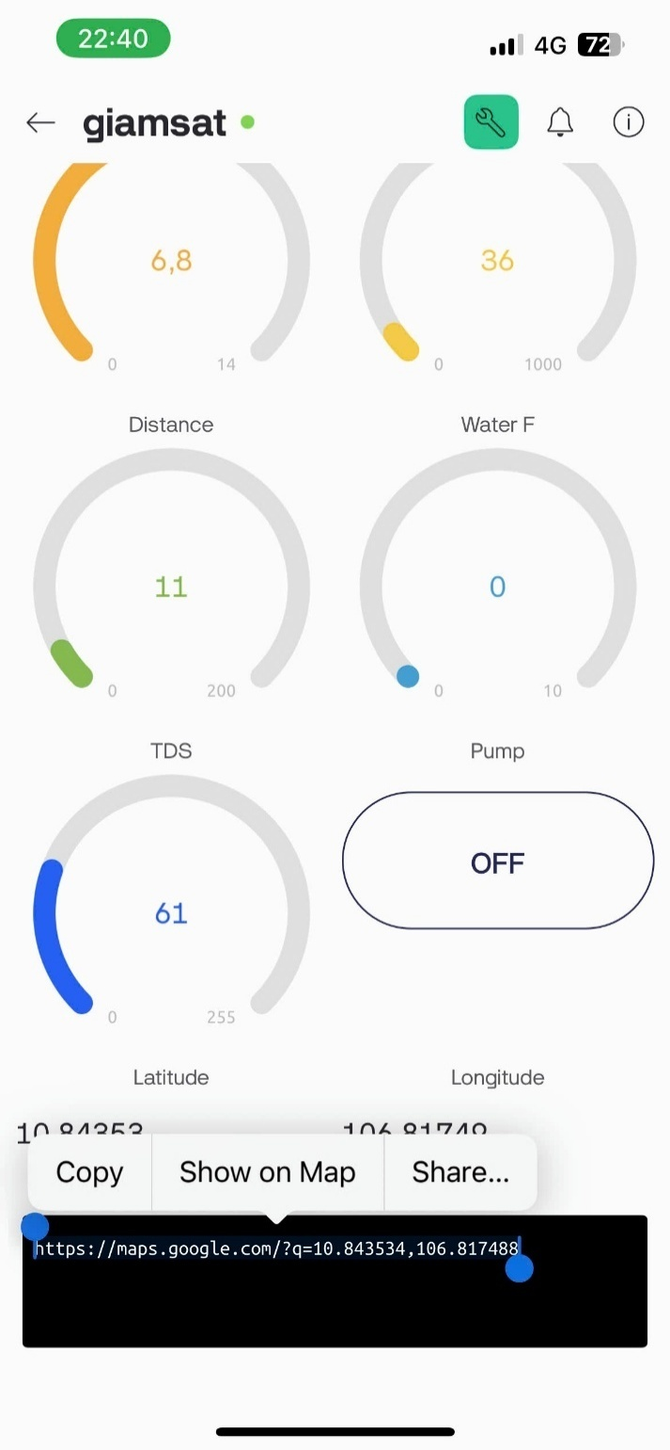

**Figure 6. 9:** GPS link from blynk app and location on google maps

At that time, the Blynk application will start receiving and directly displaying parameters from the sensors, including pH, temperature, turbidity, TDS, water level and water flow (Figure 6.10).

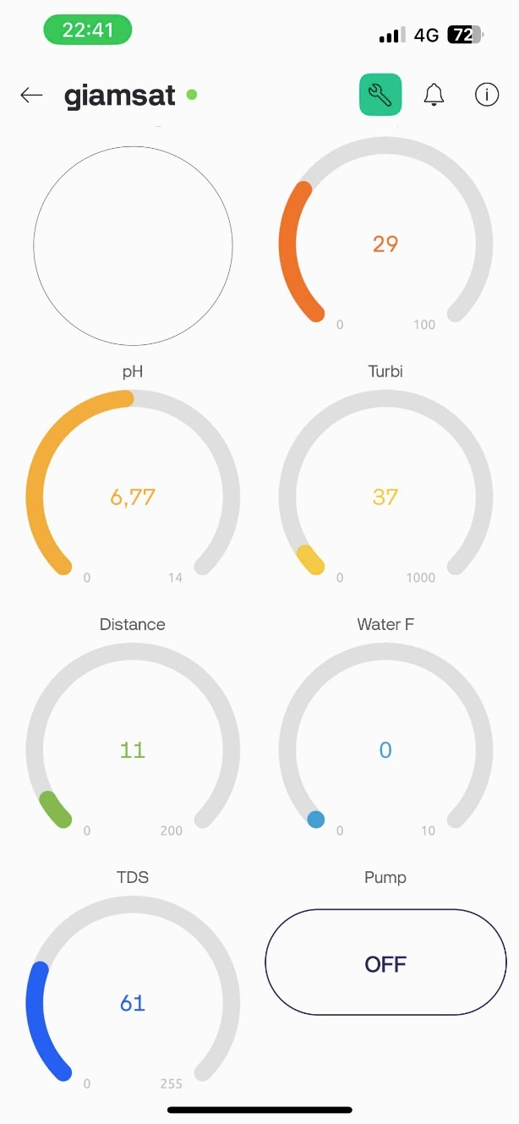

**Figure 6. 10:** Blynk application interface displaying sensor parameters.

### Evaluate the system performance in different environments.

The water quality monitoring system was tested in different environments to evaluate the accuracy of the sensors measuring pH, temperature, turbidity and water level. Among the measured parameters, pH is the most important, to create a neutral, acidic, basic water environment. I used a pH correcting powder, as shown in Figure 6.11.

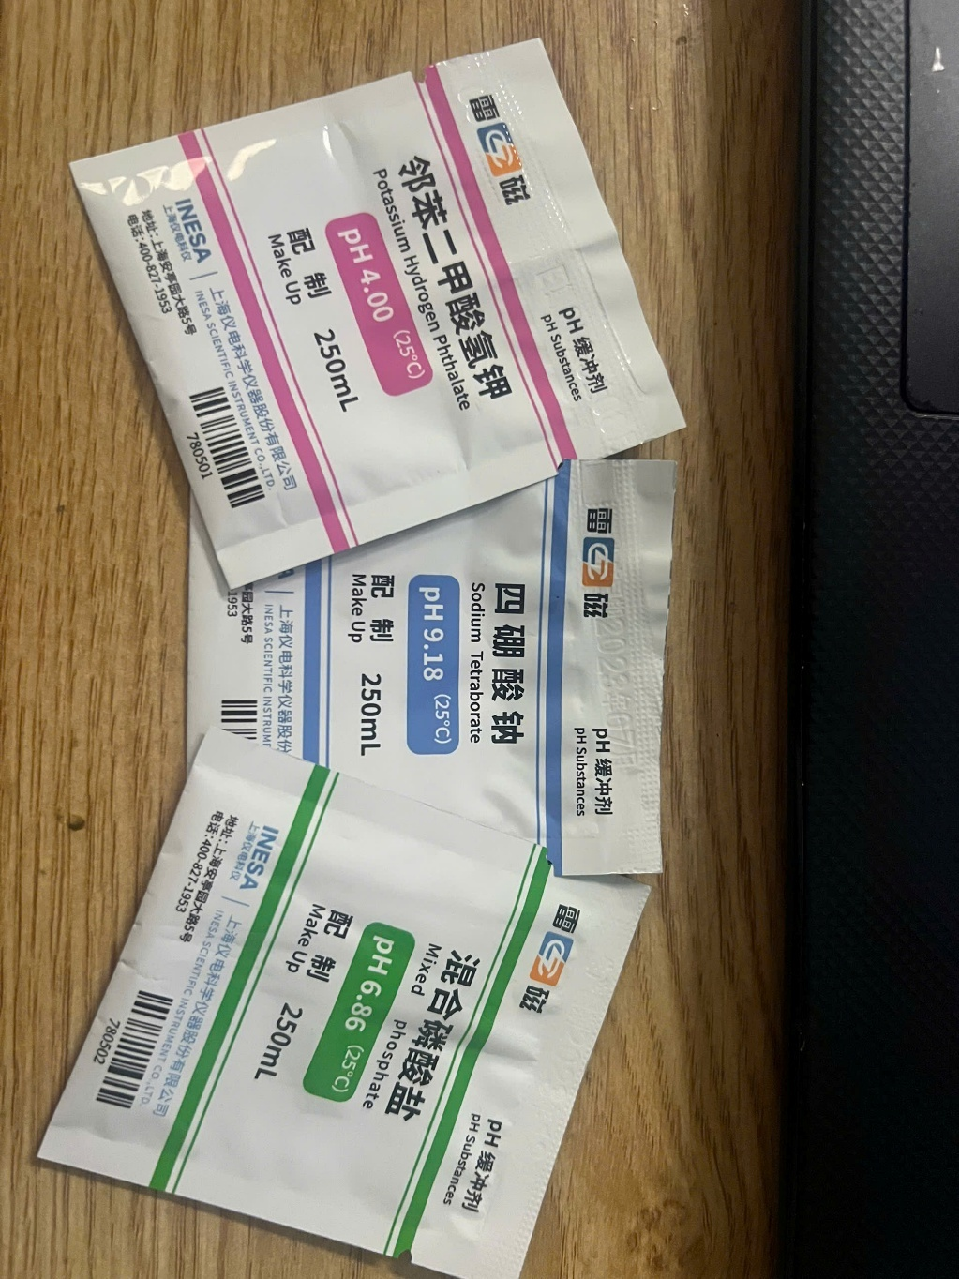

**Figure 6. 11:** pH correction package.

With pH parameters provided by the manufacturer as shown in table 6.1

**Table 6. 1:** pH correction package specifications

|  |  |  |  |
| --- | --- | --- | --- |
| **oC** | **pH4.01** | **pH6.86** | **pH9.18** |
| 10 | 4.00 | 6.92 | 9.33 |
| 15 | 4.00 | 6.90 | 9.28 |
| 20 | 4.00 | 6.88 | 9.23 |
| 25 | 4.01 | 6.86 | 9.18 |
| 30 | 4.01 | 6.85 | 9.14 |
| 35 | 4.02 | 6.84 | 9.10 |
| 40 | 4.03 | 6.84 | 9.07 |
| 45 | 4.04 | 6.83 | 9.04 |
| 50 | 4.06 | 6.83 | 9.02 |

To check the accuracy of the system after calibration, I conducted tests in three specific cases, corresponding to three different environments:

* Acidic environment: pH about 4.
* Neutral environment: pH about 6.
* Basic environment: pH about 9.

#### Case 1: Acidic environment: pH about 4.

In the first scenario, water with a low pH (around 4) was tested. The system measured a value of 4.02, which matched the results from the litmus test, confirming the accuracy of the sensor, as shown in the figures below.

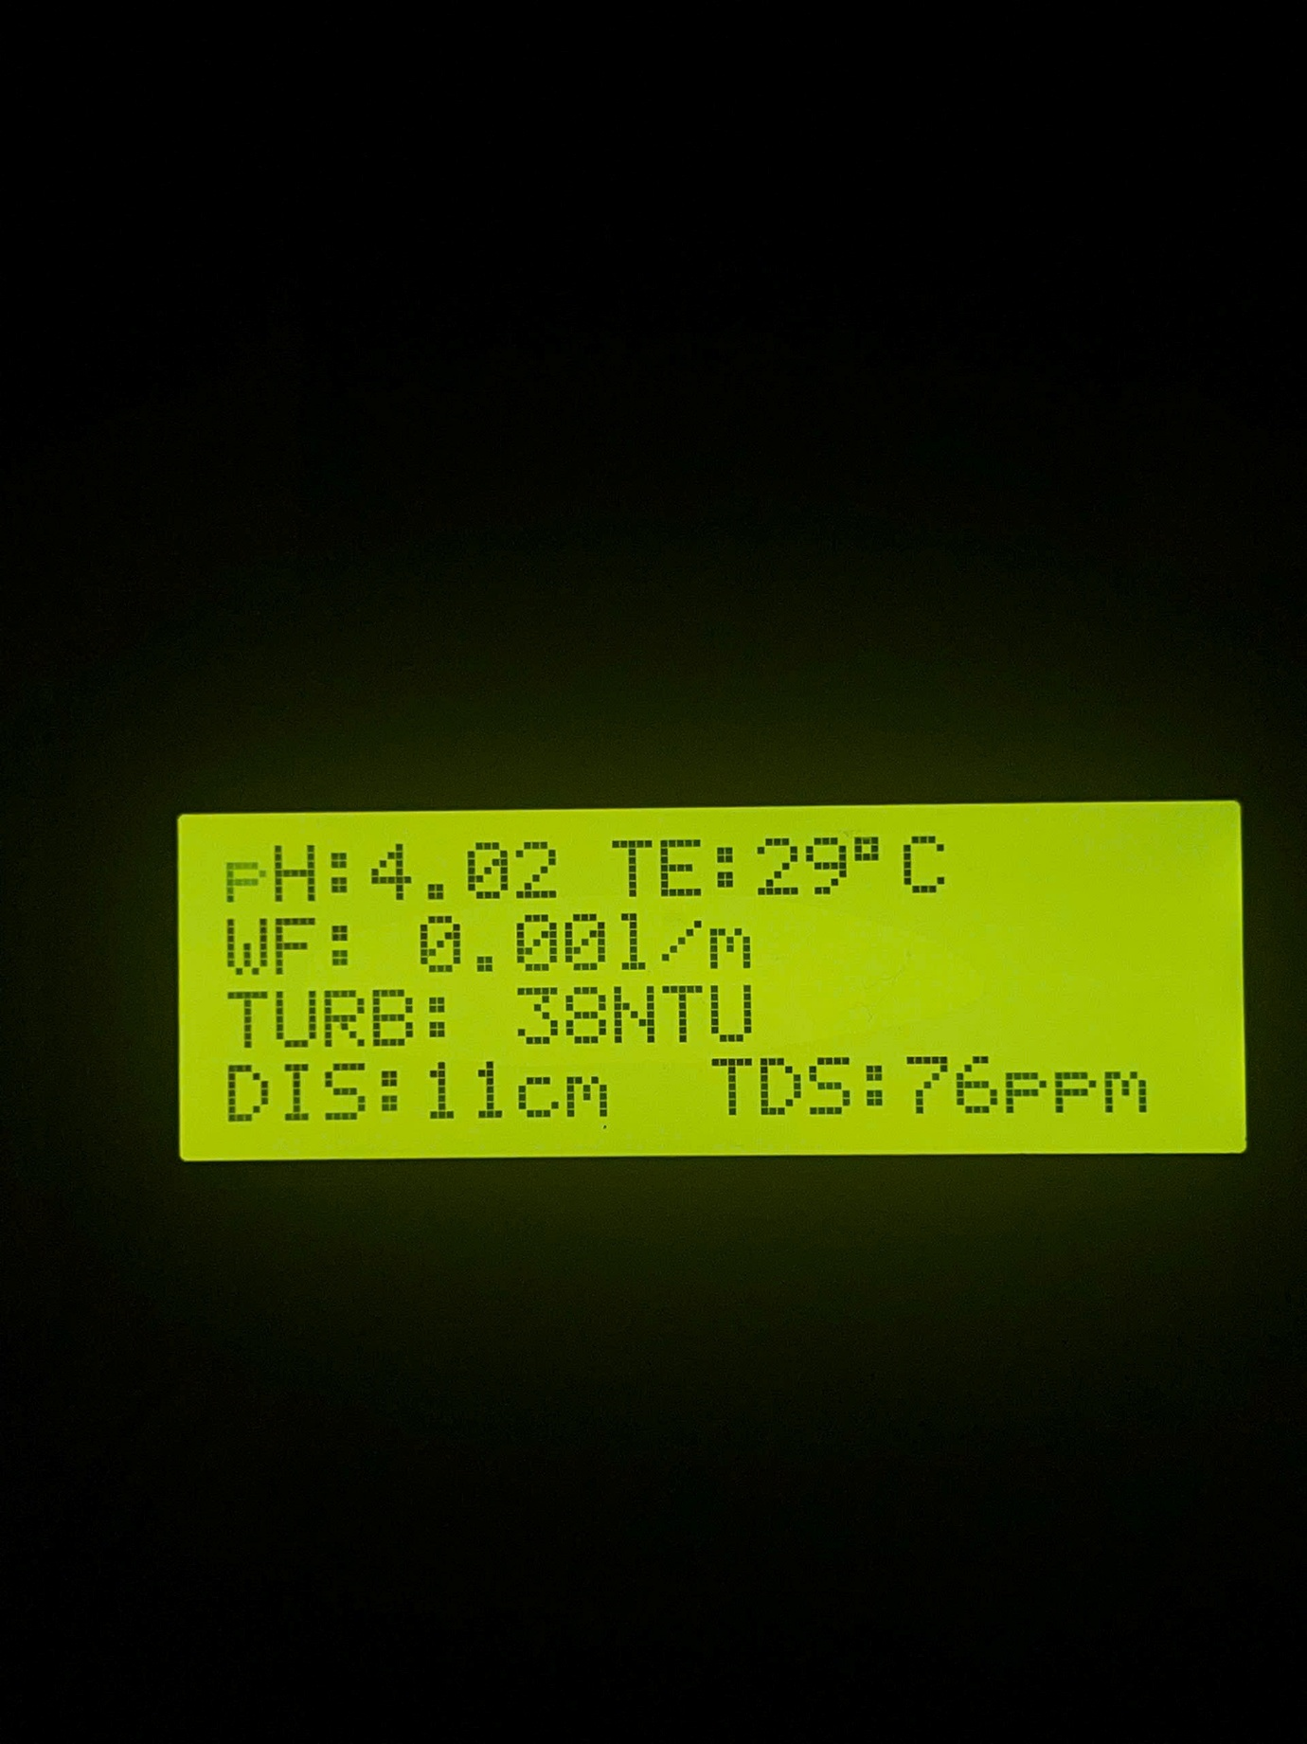

**Figure 6. 12:** Hardware system when operating with low pH water samples.

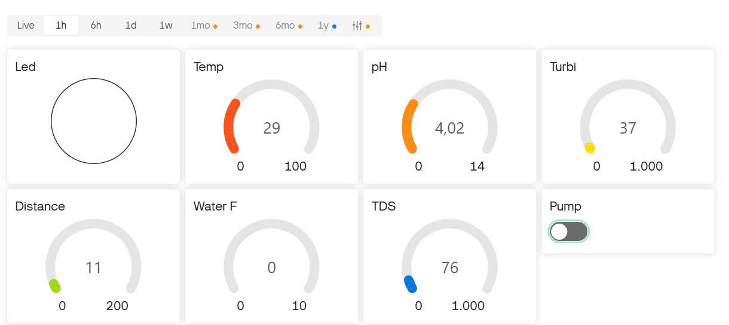

**Figure 6. 13:** Blynk interface shows pH measurement result is 4.02 with other indicators

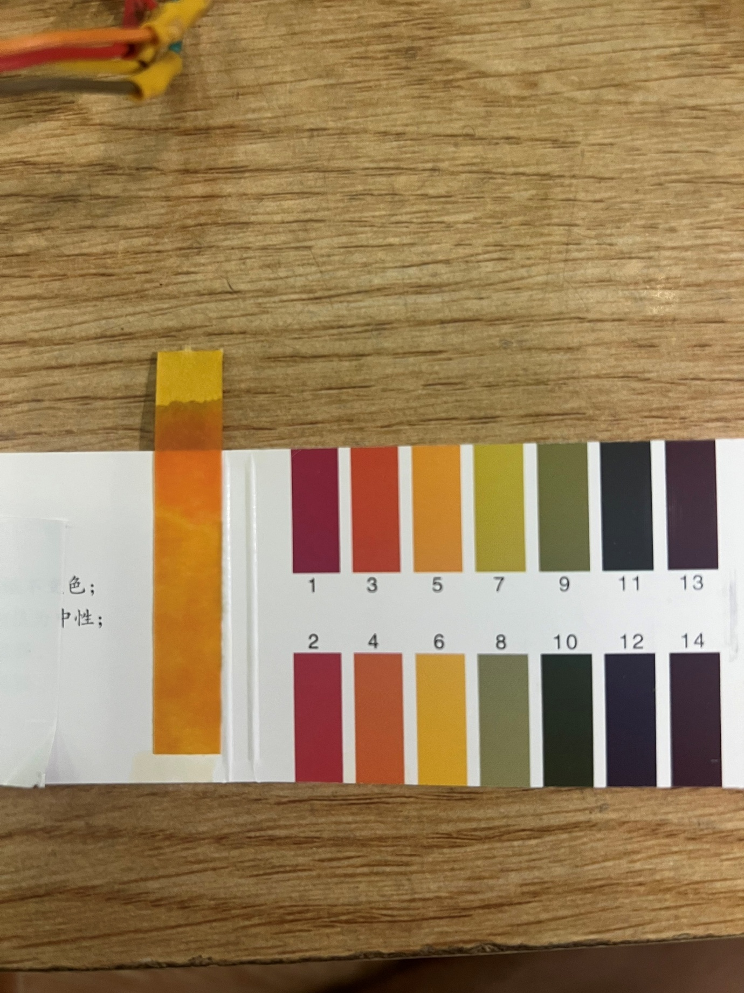

**Figure 6. 14:** The litmus test results showed that the pH was at 4.

#### Case 2: Neutral environment: pH about 6.

In the second case, water with a neutral pH (around 6.) was measured and the value returned from the system was 6.96, which is close to the litmus test result, confirming the accuracy of the sensor as:

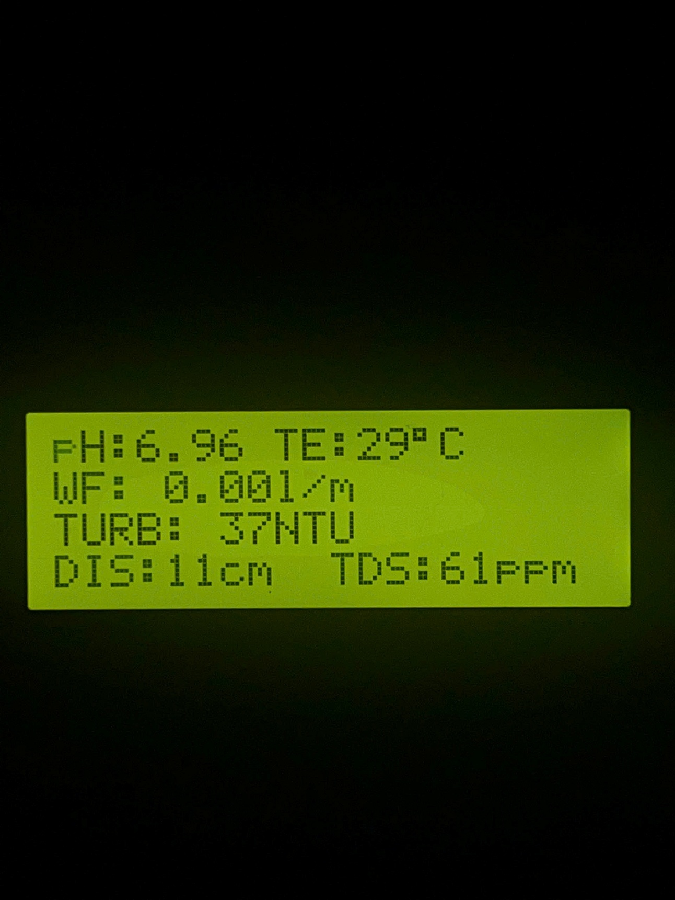

**Figure 6. 15:** Hardware system when operating with pH = 6.96 water samples.

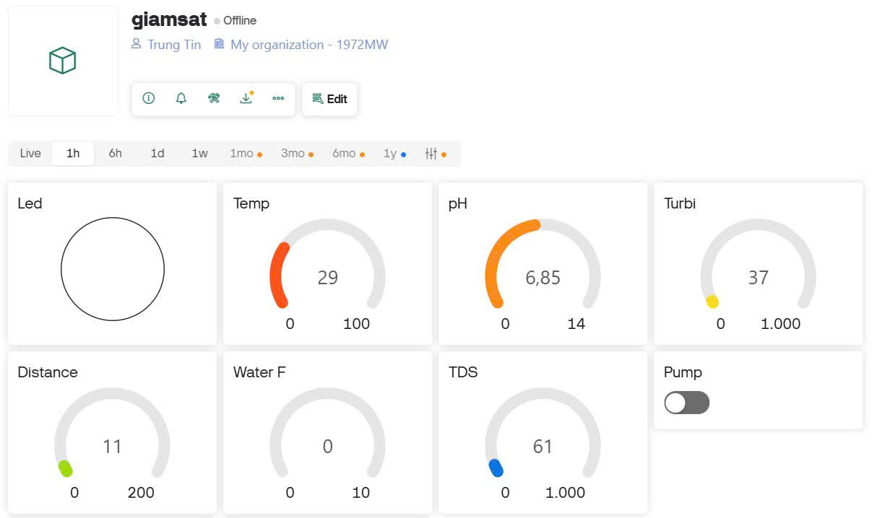

**Figure 6. 16:** Blynk interface shows pH measurement result is 6.85 with other indicators

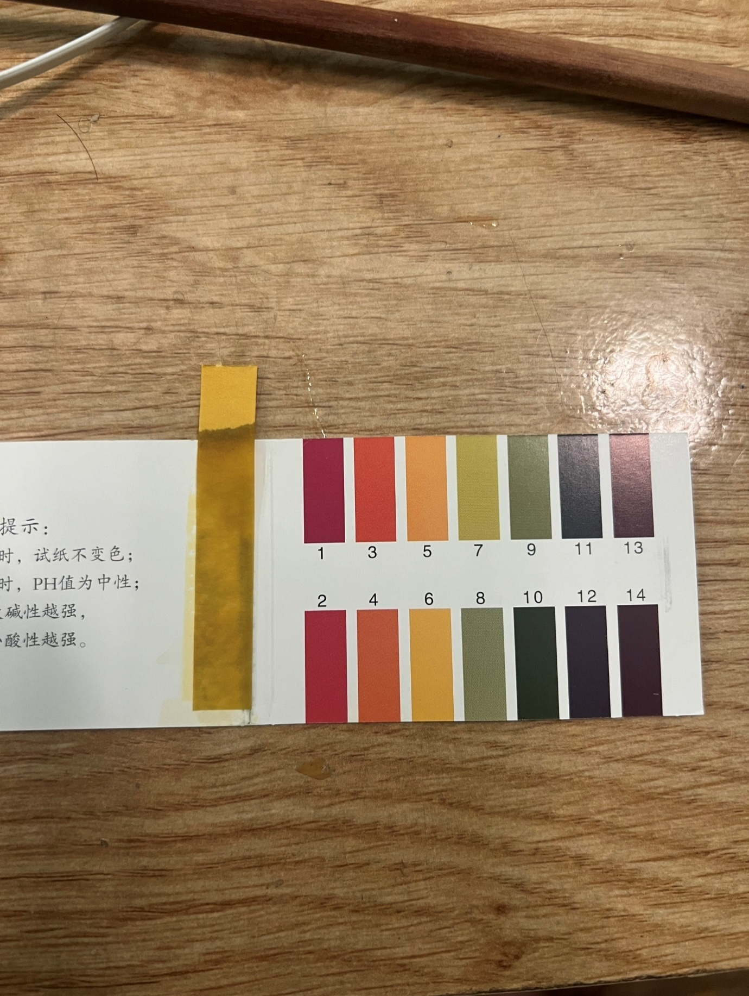

**Figure 6. 17:** The litmus test results showed that the pH was at 6

#### Case 3: Basic environment: pH about 9.

In the third test, water with a high pH (above 9) was measured and the value returned from the system was, which is close to the litmus test result. Illustrative image of the test:

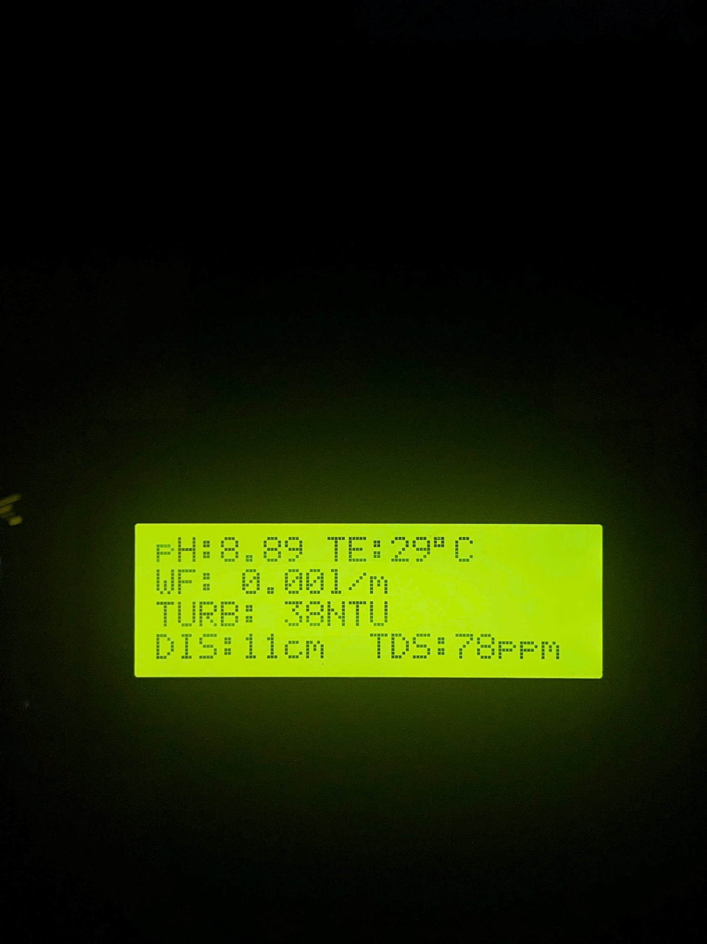

**Figure 6. 18:** Hardware system when operating with high pH water samples

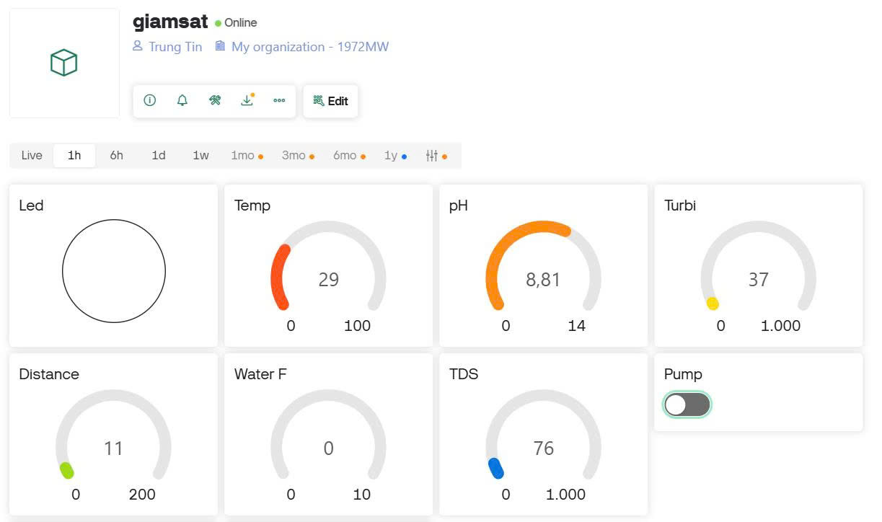

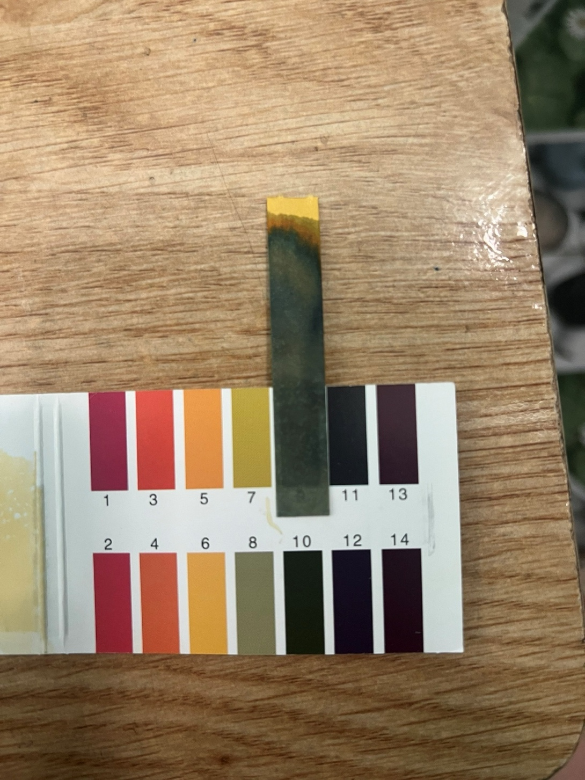**Figure 6. 19:** Blynk interface shows pH measurement result is 8.81 with other indicators

**Figure 6. 20:** The litmus test results showed that the pH was at 10

### Flow rate measurement results

To calculate the water flow in liters per minute (l/m), the formula used in the program is as follows

$$water flow= \frac{x×60}{encoder}$$

where

* Water flow is the water flow in liters/minute (l/m)
* x is the number of pulses measured in 1 second
* 60 is the conversion factor from seconds to minutes (1 minute = 60 seconds)
* Encoder is the number of pulses corresponding to 1 liter of water

The encoder coefficient is calculated according to the following process. The system uses a 385 12VDC pump motor and a YF-S401 sensor as in section **5.2.6**, using an additional 8mm water pipe and a 1-liter water measuring bottle. Count the pulses for 1 liter of water: let the pump operate and the flow sensor will start counting pulses until the bottle has enough 1 liter of water, then stop. Doing this 10 times in a row, we ontain the results in Table 6.2.

**Table 6. 2:** Number of pulses measured per liter in 10 calibration runs

|  |  |
| --- | --- |
| Number of measurements | Pulses/liter results |
| 1 | 2418 |
| 2 | 2299 |
| 3 | 2398 |
| 4 | 2340 |
| 5 | 2420 |
| 6 | 2425 |
| 7 | 2433 |
| 8 | 2361 |
| 9 | 2381 |
| 10 | 2345 |

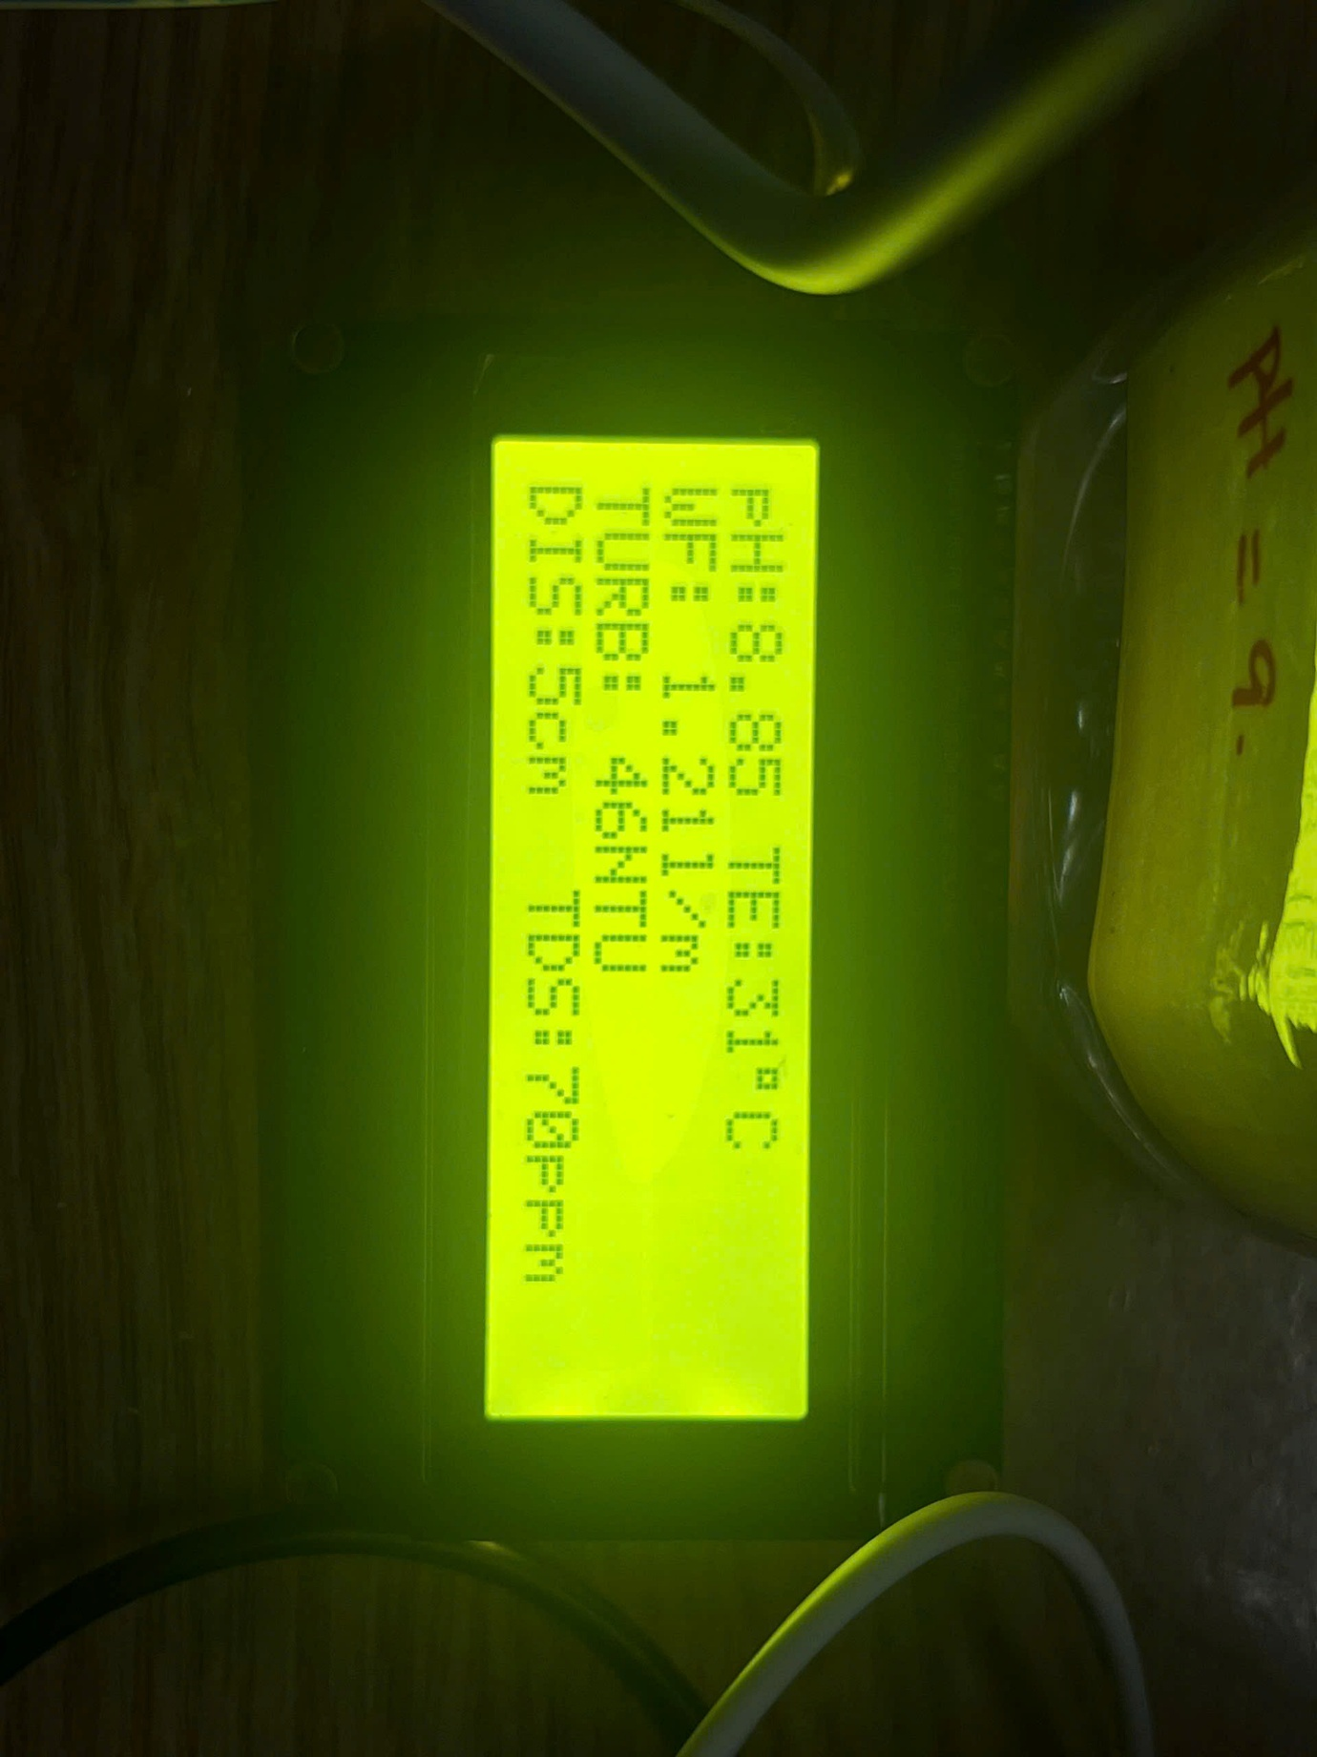Encoder average value = 2382 pulses/l

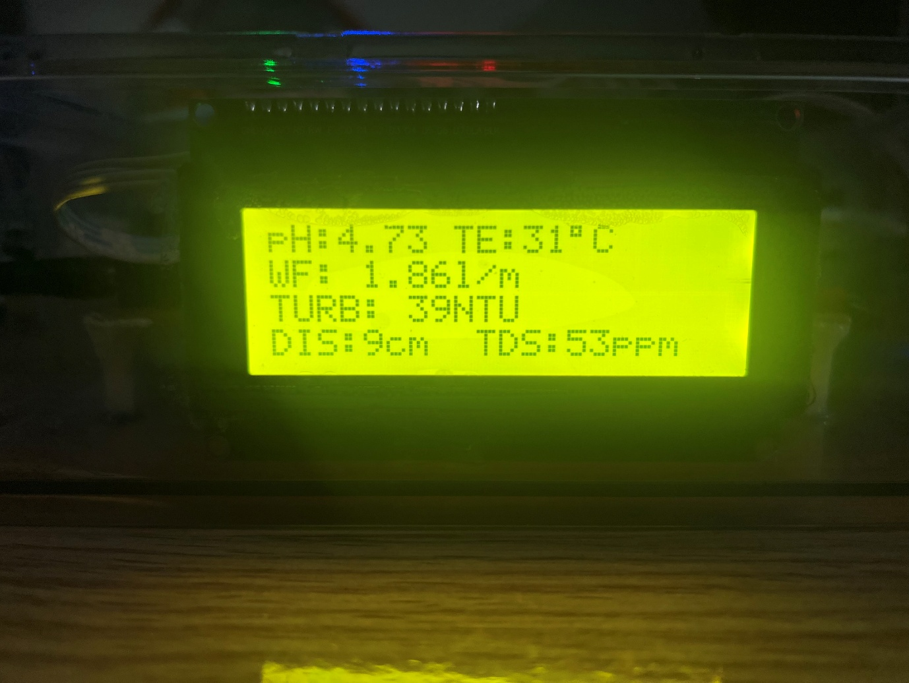Using the encoder coefficient in the actual water quality monitoring system, the system pumps water for 1 minute and the result on the LCD display is 1.86 l/m in figure 6.21 That means in 1 minute the system has pumped 1.86 liters of water. The result is almost exactly the same as the capacity of the 385 pump motor.

**Figure 6. 21:** LCD display with WF = 1.86 l/m

### Warning system test results.

About SMS alert system and red LED alert on blynk app illustrated in two cases below are turbidity and distance

#### Turbidity warning exceeds 500 NTU

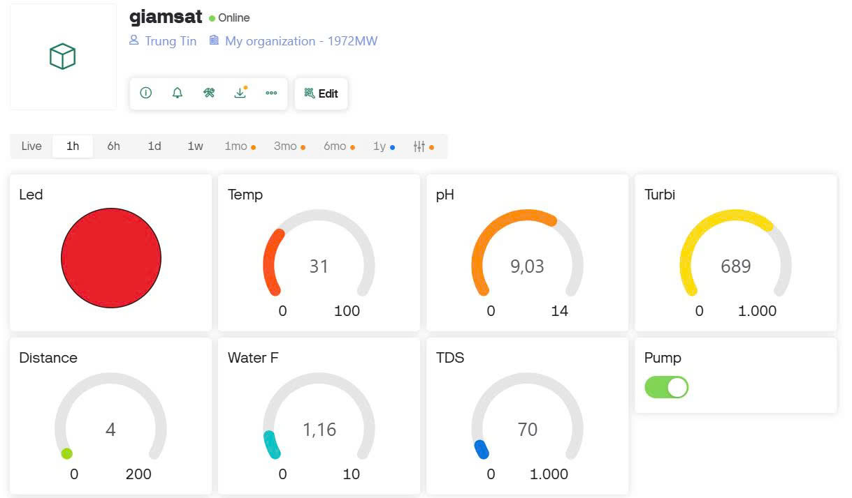When the turbidity value exceeds the warning threshold exceeds 500 NTU (689 NTU), the warning LED turns red (figure 6.22) to attract attention.

**Figure 6. 22:** Turbidity alert on Blynk

Warning sent via SMS using 4G module with turbidity value: 619 NTU in Figure 6.23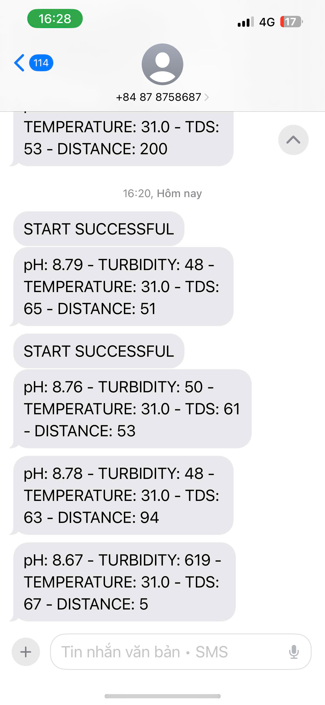

**Figure 6. 23:** SMS alert with turbidity: 619 NTU

#### Distance warning exceeds 60

When the distance value exceeds the warning threshold exceeds 60 (200), the warning LED turns red (figure 6.24) to attract attention.

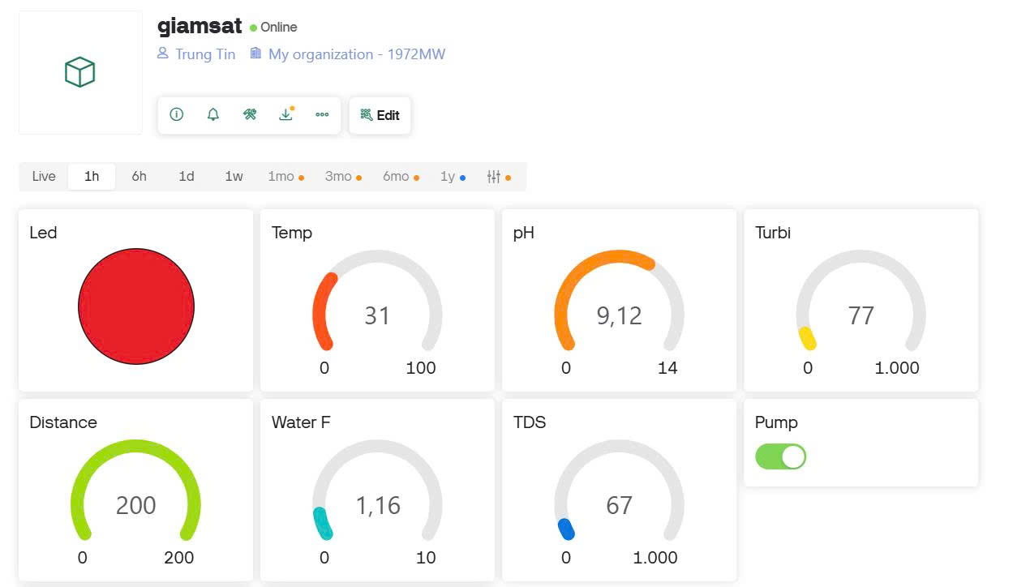

**Figure 6. 24:** Distance alert on Blynk

Warning sent via sms using 4G module with distance value: 200 in figure 6.2.

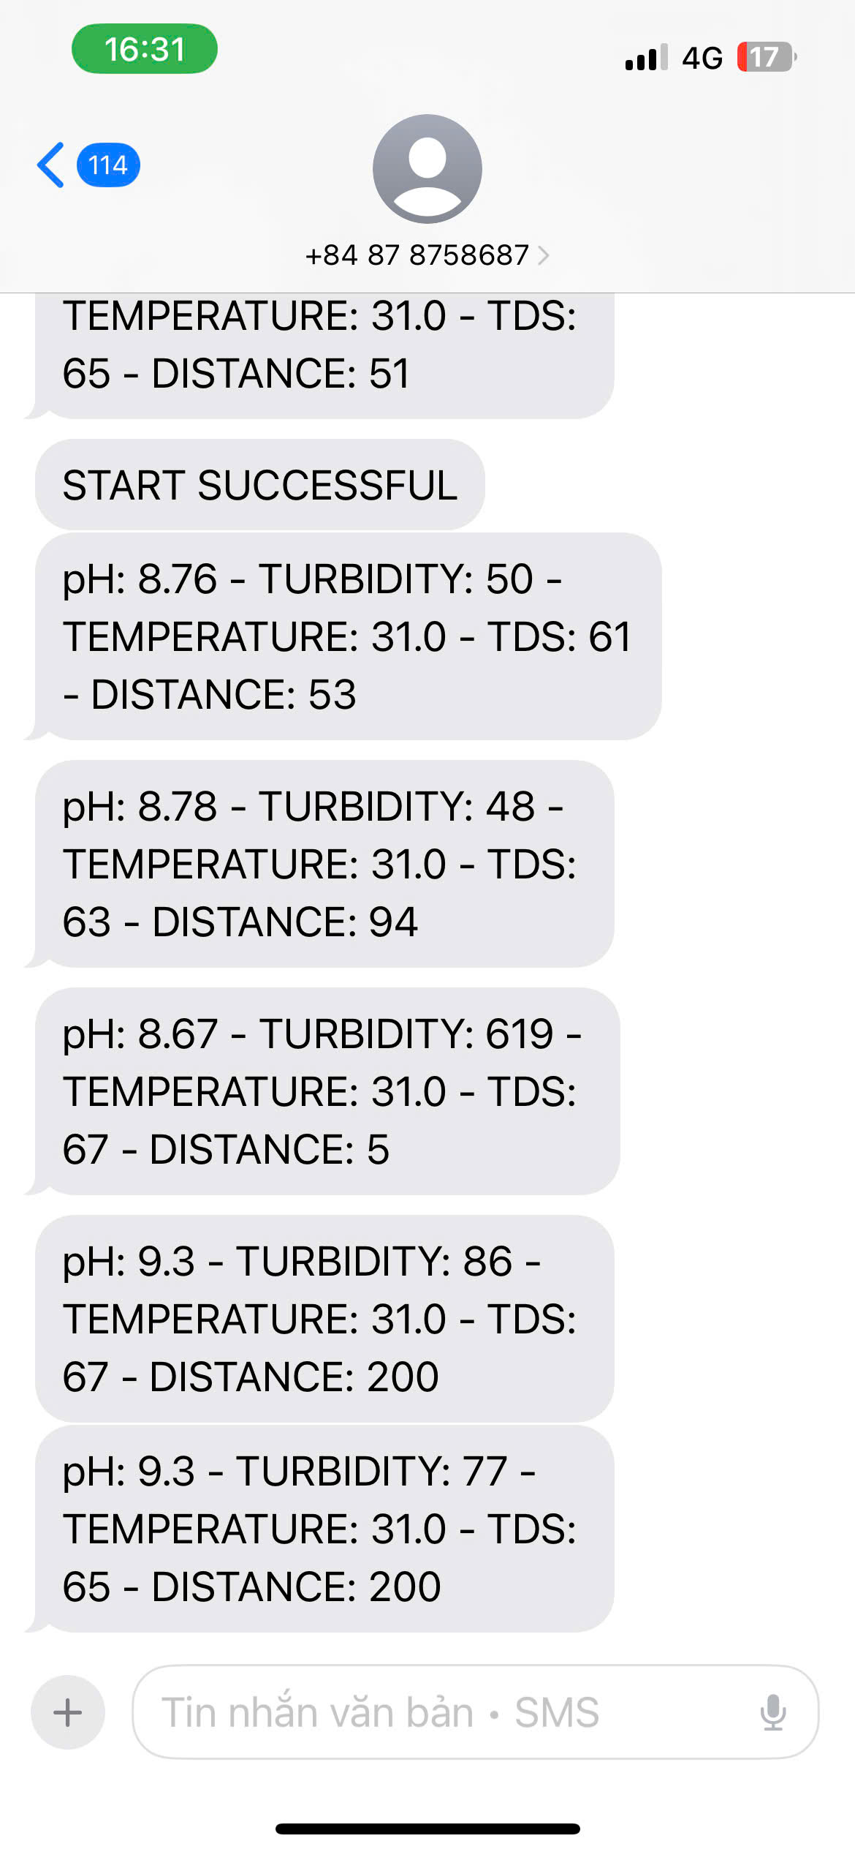

**Figure 6. 25:** SMS alert with distance: 200

## QR code for test data archive

Figure 6.26 shows the QR code leading to the Google Drive folder containing images and videos of the entire testing process in Chapter VI.

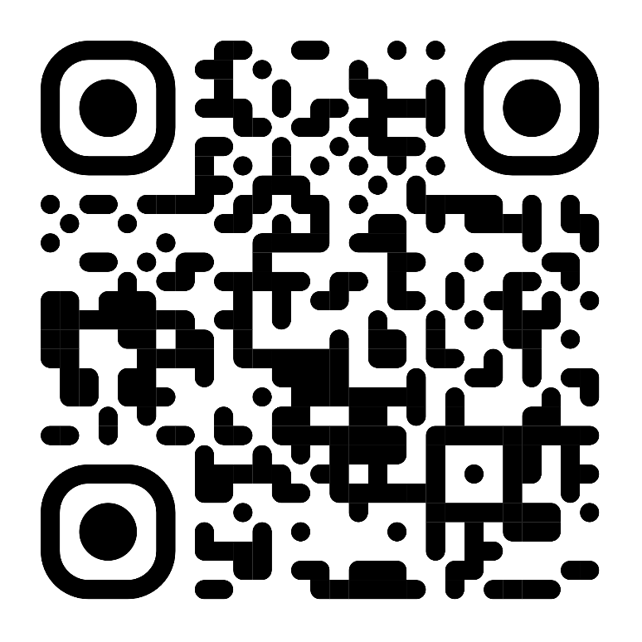

**Figure 6. 26:** QR Code leading to thesis results folder

## Discussions

### Discussion 1

The above results demonstrate the stability of the system. The measured parameters including temperature, pH, turbidity, TDS, water level, flow rate and GPS location are continuously transmitted and displayed in real time on the Blynk application. For example, the pH measured for the environment is approximately the same as the pH calibration package. The TDS values ​​range from 50 to 600 ppm, indicating the water hardness in each environment, supported by the classification in Figure 5.7. The temperature reading, recorded at 29 to 33 °C, is typical for ambient water under normal conditions. The system also effectively triggered alerts through the Blynk virtual LED and SMS messages when thresholds were exceeded. For instance, when turbidity surpassed 100 NTU, the dashboard displayed a red LED and a message was sent via the A7682S 4G LTE module, showing that the warning mechanism was functional and responsive.

Compared to the previous studies referenced in Chapter IV, this system offers several improvements: integration of more sensors (including GPS and TDS), dual communication methods (Wi-Fi and 4G) and integrated real time control via mobile application. Particularly the replacement with 4G module when the system of Kavita Katole, Yashoj Narnaware [9] section 4.1.1 uses 2G sim module which is completely cut off in Vietnam. The ability to monitor flow through pulse-based sensors has added an additional layer of understanding to detect abnormal water usage.

### Iterative decision-making process

To ensure the system was both functional and reliable, an iterative decision-making approach was applied throughout the design and development stages. At each step, problems were identified, multiple solutions were considered, and decisions were made based on effectiveness, simplicity, and system stability. Table 6.3 summarizes the key challenges encountered, the alternatives evaluated, the final choices made, and improvements suggested for future development.

**Table 6. 3:** Iterative decision-making process

|  |  |  |  |  |  |
| --- | --- | --- | --- | --- | --- |
| **Objectives** | **Problems** | **Iterative Process** | **Decision Making** | **Achieved/**  **Overcome** | **Improvements needed** |
| **Objective 1:**  Select communication method for data transmission | **Problem1:** Wi-Fi unavailable in some test areas | **Approach 1**:  Use only ESP8266 Wi-Fi  **Approach 2**:  Add A7682S 4G module for SMS alerts | Compared coverage, latency, and cost. Chose **Approach 2** for better reliability | System functions even without Wi-Fi thanks to 4G backup | Optimize power usage when both Wi-Fi and 4G are active |
| **Problem 2:**  ESP8266 reset during long operation | **Approach 1**:  Power from Arduino 5V pin  **Approach 2**:  Power ESP8266 via Vin (5V) to use onboard LDO 3.3V | Selected **Approach 2** for better stability and separation from Arduino's 5V line | Reduced reset issues under load | Add capacitor near ESP8266 for noise filtering |
| **Objective 2:**  Accurate water parameter monitoring | **Problem 1:**  Inconsistent pH sensor readings | **Solution 1**:  Use raw sensor output  **Solution 2**:  Calibrate with pH powder solution | **Solution 2** chosen for higher accuracy and repeatability | Sensor returned expected values (4.02 / 6.85 / 8.81) in all tests | Consider 2-point calibration for better accuracy |
| **Problem 2:**  Turbidity values not linear | **Solution 1**:  Use basic analog reading  **Solution 2**:  Average multiple readings + calibration curve | **Solution 2** produced more stable turbidity values by minimizing fluctuations and aligning closer to expected NTU benchmarks. | Matched well with NTU references | Could apply software filtering for noisy data |
| **Objective 3:**  Real-time remote monitoring & warning | **Problem 1:**  Delay in warning via Blynk | **Method 1**:  Send only via Blynk  **Method 2**:  Send SMS + Blynk  **Method 3**:  Add LED virtual indicator | **Method 2** was selected for its dual-channel alerting via SMS and Blynk, ensuring warnings are received even if the app is offline or disconnected. | SMS alerts received even when app disconnected | Auto-resend SMS after delay can improve reliability |
| **Problem 2:**  Flow rate calculation inaccuracy | **Method 1**:  Use default pulse formula  **Method 2**:  Calibrate using manual pulse counting | **Method 2** gave more accurate L/m result | Matched pump spec at 1.86 L/min | Can improve by using higher-resolution sensor |
| **Problem 3:**  LCD displayed unstable or blinking characters when updating during SMS transmission | **Method 1:**  Display text starting from (0,0)  **Method 2**:  Shift display to start from (1,0) to avoid conflicts | Chose **Method 2**, avoided (0,0) position to reduce visual glitches during communication | Improved LCD stability during SMS sending without disabling display | Consider flag-based control to manage LCD updates dynamically |

# CONCLUSIONS AND FUTURE WORK

## Conclusions.

During this senior project, I have gained extensive knowledge and practical experience in developing an IoT-based water quality monitoring system. This includes learning about integrating sensors such as DS18B20 (temperature sensor), pH sensor, turbidity sensor, and ultrasonic sensor with Arduino UNO microcontroller. We also developed skills in using ESP8266 and GSM module for wireless communication and data transmission.

Furthermore, this project also provided me with practical experience in circuit design, as well as practical techniques in assembling and testing hardware systems. I have also improved my skills in working with Blynk IoT platform to create a user-friendly interface for remote monitoring and management.

Although the current system is stable, there are still parts that need to be optimized and improved. In the future, I will improve the efficiency of the system, expand the monitoring capabilities by adding more sensors, and improve the reliability of communication channels to ensure seamless operation in various environments.

## Future work.

An IoT-based water quality monitoring system has been successfully developed to measure parameters such as temperature, pH, turbidity, and water level. While the current system meets the main goals of real-time monitoring and remote access, there are still limitations that need to be addressed. For example, the system’s reliance on Wi-Fi to transmit data to the cloud can be problematic in areas with unstable Internet connections. The accuracy of some sensors could be further optimized to be able to identify clean, polluted, or highly polluted water.

In the future, to expand the system for broader applications such as aquaculture monitoring and household water safety, I would like to see some improvements. First, improving the accuracy and stability of the main sensors, especially for pH, turbidity and TDS, would allow the system to better classify water conditions as clean, polluted or highly polluted. Second, integrating additional sensors such as dissolved oxygen and salinity sensors, to provide a more comprehensive assessment of water quality. This classification is essential for both aquatic health and public safety. Finally, another potential improvement involves applying AI-based analytics to predict water quality and provide proactive alerts, ensuring timely intervention.

# BUSINESS, SOCIAL AND ETHICAL CONSIDERATIONS

## Business considerations

The proposed IoT-based water quality monitoring system demonstrates strong potential for real-world application in various business sectors, particularly in environmental services, agriculture, aquaculture, and rural infrastructure development. Its relatively low cost, modular design, and ability to provide real-time data make it feasible for commercialization, especially in markets that require scalable and affordable monitoring solutions.

## Social considerations

This system is useful in daily life, especially in rural or low-income areas where people rely on wells, rainwater or rivers for their daily water use. The system helps detect unsafe water sources early and alerts users when water quality is poor, helping to protect health and prevent diseases. In fish or shrimp farming, the system can monitor water conditions such as pH, turbidity and temperature, and alert farmers when the values ​​are out of range, increasing productivity. Because it uses simple components and works with mobile phones, the system is easy to use, low cost and suitable for many different places. The system supports access to clean water and helps people take good care of their water resources and the environment.

## Ethical considerations

This project did not involve any people or animals in testing, and no personal information was collected. The hardware and software used are open-source and safe for learning and development. In the future, if the system is used in communities or public areas, it is important to use the data carefully. People should know how the data is used, and alerts must be clear and correct to avoid confusion. The system should always be used to help imp

# REFERENCES

[1]. https://doctorhouses.com/tam-quan-trong-cua-nuoc-va-giai-phap-cuu-nguon-nuoc-sach.html

[2]. https://vtv.vn/xa-hoi/nguon-nuoc-o-nhiem-co-the-gay-ton-that-toi-35-gdp-moi-nam-20240329195002844.htm

[3]. https://www.usgs.gov/special-topics/water-science-school/science/vong-doi-cua-nuoc-water-cycle-vietnamese

[4]. Ogundele Joshua, Francis Enejo Idachaba, Onyinyechi Steve-Essi, “Design and Implementation of a Smart Water Monitoring System (IoT) Using Arduino Microcontroller”, College of Engineering, College of Engineering, Covenant University, Covenant University, 2022

[5]. S. Kavi Priya, G. Shenbagalakshmi, and T. Revathi, "Design of smart sensors for real-time drinking water quality monitoring and contamination detection in water distributed mains", International Journal of Engineering & Technology, Vol. 7, pp42-51. 2018

[6]. N. Andre Cloete, R. Malekian and L. Nair, "Design of Smart Sensors for Real-Time Water Quality Monitoring”, Journal of IEEE Access, Vol. 13, No. 9, September 2014.

[7]. P. B. Bokingkito Jr and O.E. Llantos, "Design and Implementation of Real-Time Mobile-based Water Temperature Monitoring System", Procedia Computer Science, Vol.123, pp. 698-705, 2017.

[8]. M. Pule, A. Yahya and J. Chuma, "Wireless sensor networks: A survey on monitoring water quality. Journal of Applied Research and Technology", Vol. 15, 562-570, January 2018.

[9]. Kavita Katole, Yashoj Narnaware, Banshikha Biswas, Dimpal Patle, “Design & Implementation of Water Quality Monitoring & Notification  
System”, International Research Journal of Engineering and Technology (IRJET), 2019.

[10]. Ogundele Joshua Iyanuoluwa, Steve-Essi Onyiyechi, Francis Idachaba, “Design and Implementation of a Smart Water Monitoring System (IoT) Using  
Arduino Microcontroller”, College of Engineering, Covenant University, 2022.

[11]. Jomsuda Duangwongsa, Thepparath Ungsethaphand, Pradchayaporn Akaboot, Supakit Khamjai, Syan Unankard, “Real-time Water Quality Monitoring and  
Notification System for Aquaculture”, The 6th International Conference on Digital Arts, Media and Technology (DAMT) and 4th ECTI Northern Section Conference on Electrical, Electronics, Computer and Telecommunications Engineering, 2021.

[12]. M. P. P. Sithole, N. I. Nwulu, E. M. Dogo, "Development of a Wireless Sensor Network Based Water Quality Monitoring and Notification System", Department of Electrical and Electronic Engineering Science, University of Johannesburg, South Africa, 2019.

[13]. Mohd Sallehin Mohd Kassim, Mohd Rifqi Rozman, Aznida Abu Bakar Sajak, Rula Alrawashdeh, "IoT Water Quality Monitoring for Smart City”, Article in International Journal of Advanced Trends in Computer Science and Engineering, September 2020.

[14]. <https://doctorhouses.com/tam-quan-trong-cua-nuoc-va-giai-phap-cuu-nguon-nuoc-sach.html>

# APPENDICES

**Appendix A: Arduino source code for sensor acquisition and SMS alert**

This code runs on an Arduino board to continuously collect environmental water parameters including pH, turbidity, temperature, TDS, flow rate, and water level. It also evaluates threshold conditions and sends real-time warning messages via a 4G LTE module (A7682S). An LCD is used to display real-time values. Key functionalities:

* Read sensor values via analog pins and digital input
* Display values on I2C LCD
* Monitor threshold values and trigger SMS alerts
* Send serial data to ESP8266 for remote monitoring

**Appendix B: ESP8266 Code for IoT Communication via Blynk**

This program runs on an ESP8266 NodeMCU. It receives data from Arduino through UART, parses multiple sensor values, and updates them in real time to the Blynk IoT platform. The device also uses a GPS module to retrieve geolocation coordinates and visualize them on a map. Key functionalities:

* Receive UART data with basic packet structure (e.g., 'a', 'b', 'c')
* Display pH, turbidity, TDS, temperature, and distance on Blynk virtual pins
* Periodically update location using TinyGPS++
* Provide remote warnings via LED widget and Google Maps link